Centralia College
Student Activities Team (SAT) Application

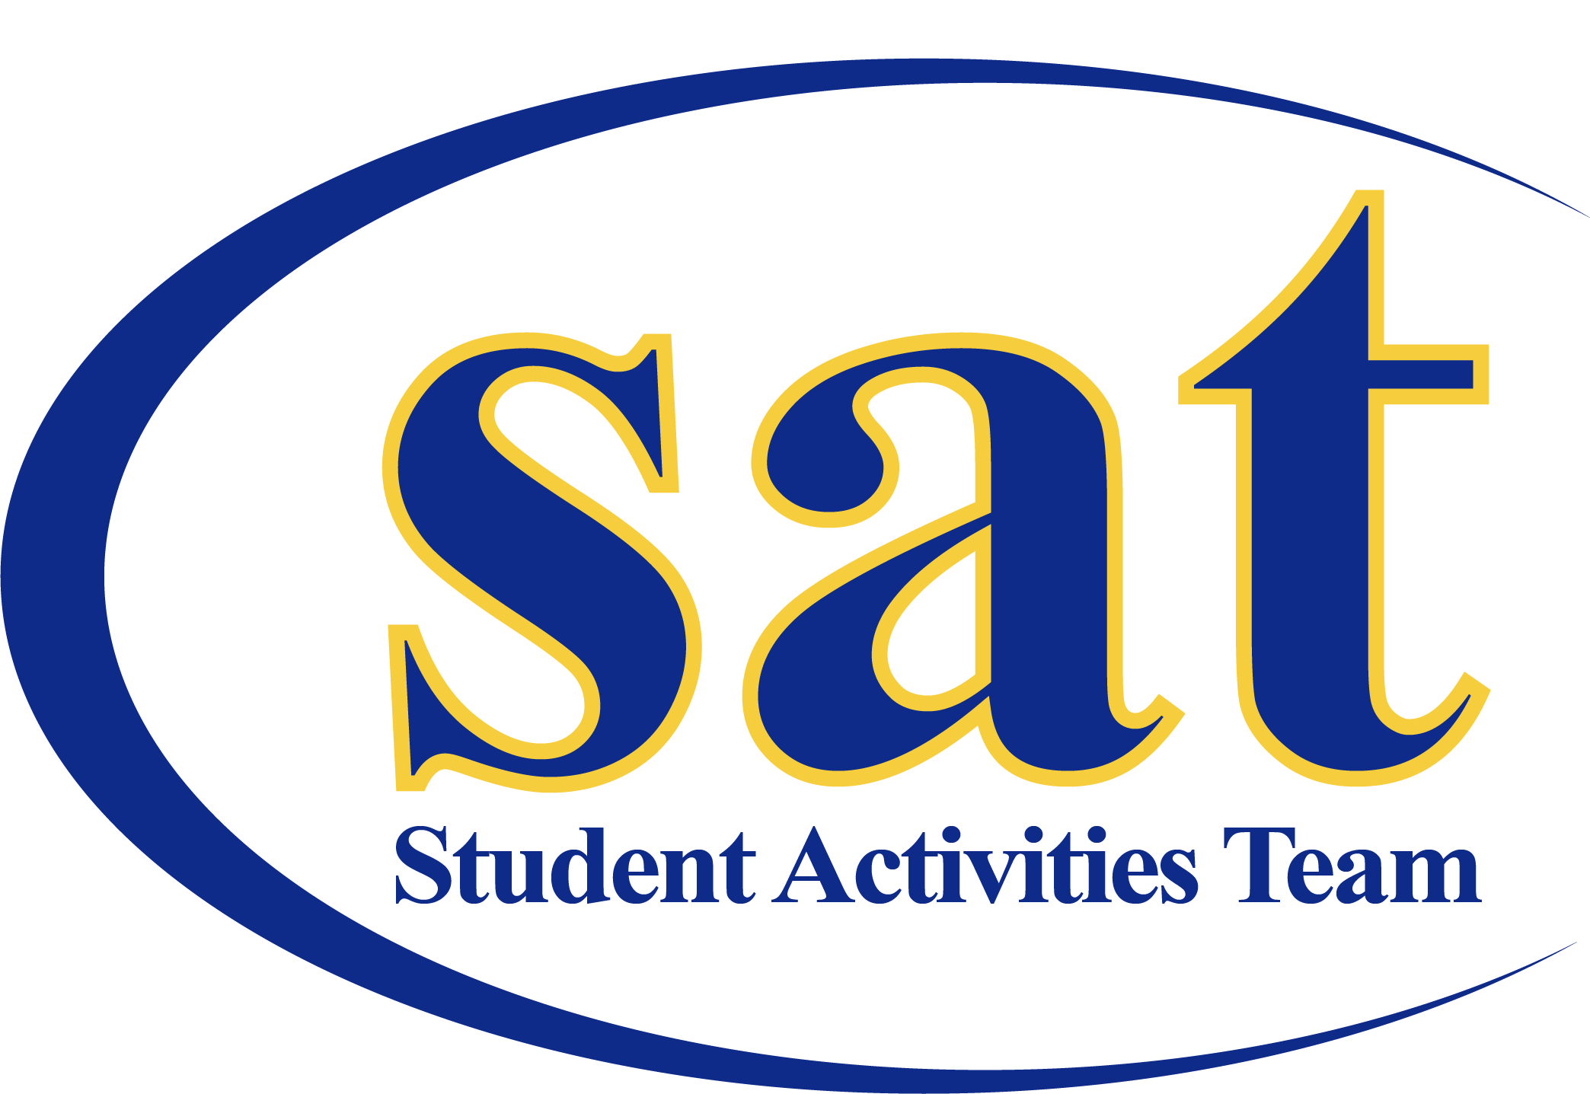

Application deadline: April 24, 2020 or until positions filled –
Submit applications via email to Jessica Ramirez at jessica.ramirez@centralia.edu
Period of employment: August 17, 2020 – June 18, 2021

Student Activities Team

Application Checklist

Student Activities Team (SAT) Application Checklist
- Complete SAT application
- Resume
- Essay question answered
Application Deadline
- First review of applications begins Monday April 27, 2020. All positions are open until filled.
- Email application to Jessica Ramirez at Jessica.ramirez@centralia.edu
Interview:
- Individual Interviews, which will begin the week of April 27th and continue until completed. Students will receive a 30-minute time slot. Please be on time for your interview and dress appropriately.

Questions:
- Contact Jessica Ramirez at jessica.ramirez@centralia.edu or
call/text at 360-562-0847

Student Activities Team

Position Description

Position: Student Activities Team Coordinator
Division: Student Life | Reports to: Assistant Director of Student Life

What is SAT?
Student Activities Team is committed to establish student driven programs and events that meet our students’ diverse needs. Our goal is to have at least one cultural, educational, health and wellness, entertainment, and family event per quarter.
SAT provides students with the opportunity to become involved in planning, promoting, implementing and assessing events. We present opportunities for students to learn, grow and develop into quality leaders.

Qualifications
- Be enrolled at Centralia College with a minimum of 6 college level credits.
- Be in good disciplinary standing with the college.
- Have and maintain a cumulative & quarterly grade point average of 2.5 or higher.
- Experience (volunteer or paid): working in a team environment, organizing events and collaborating with groups.
- Must completely fill out all parts of the SAT application.

Positions Available/ Descriptions
SAT students can work up to 15 hours per week
The responsibilities of the Student Activities Team (SAT):
- Initiate and coordinate student activities;
- Select, schedule and implement SAT – sponsored events;
- Provide opportunities for individual leadership development and for group participation;
- Plan, organize, budget and facilitate 3 events each quarter
- Track event attendance and administer event evaluations;
- Assist with quarterly ASCC & SAT Welcome Week event and activities
- Work as a team to schedule vendors and performs for Spring Fest;
- Attend designated weekly team meetings and 1:1 meetings with Assistant Director of Student Life
- Maintain academic eligibility;
- Affirm and support the Centralia College Mission and Vision statement.
- Attend all SLIC sponsored leadership trainings, retreats and conferences.
- Members of the SAT will be required to participate as college representatives at selected activities and events arranged by Director of Student Life and/or Assistant Director of Student Life
- Other duties as requested by Director of Student Life and the Assistant Director of Student Life

Compensation:
- You will be paid hourly at the minimum wage rate
- Office hours will be held Monday – Friday 8:00 am – 5: 00 pm and flex with evening events

Commitment Dates: all dates are subject to change
May 20, 2020 Recognition Night
June 19, 2020 Graduation Reception
August 17 – Sept. 10, 2020 Training
Sept. 2-4, 2020 Student Leadership Conference in Pasco, WA (overnight)
Sept. 17, 2020 Trailblazer Kickoff
Sept. 21, 2020 First day of Fall Qt.
Nov. 19 – 22, 2020 NACA West, Spokane, WA (overnight)

Student Activities Team

Application

Name: Click or tap here to enter text. Email: Click or tap here to enter text.
Address: Click or tap here to enter text.
Phone number: Click or tap here to enter text. SID#: Click or tap here to enter text.
Credit Hours for Fall Quarter 2020:Click or tap here to enter text.
Major Area of Study: Click or tap here to enter text.
Expected Date of Graduation: Click or tap here to enter text. Cumulative GPA: Click or tap here to enter text.

Prior work or volunteer experience:
Please begin with your most recent experience.
Employer or Organization: Click or tap here to enter text.
Date of employment: Click or tap here to enter text. To Click or tap here to enter text.
Your title: Click or tap here to enter text.
Description of your duties: Click or tap here to enter text.
Reason for leaving: Click or tap here to enter text.
Employer or Organization: Click or tap here to enter text.
Date of employment: Click or tap here to enter text.to Click or tap here to enter text.
Your title: Click or tap here to enter text.
Description of your duties: Click or tap here to enter text.
Reason for leaving: Click or tap here to enter text.
Employer or Organization: Click or tap here to enter text.
Date of employment: Click or tap here to enter text. To Click or tap here to enter text.
Your title: Click or tap here to enter text.
Description of your duties: Click or tap here to enter text.
Reason for leaving: Click or tap here to enter text.

Professional references:
Please list individual who have firsthand knowledge of your skills and abilities, who aren’t related to you
Name, Title, & Employer/Company
Click or tap here to enter text.
Telephone:  Click or tap here to enter text. | Email:  Click or tap here to enter text.

Name, Position & Employer/Company
Click or tap here to enter text.
Telephone:  Click or tap here to enter text. | Email:  Click or tap here to enter text.

Please list any campus or community activities you are involved with.
Example: clubs, organizations, community service, etc. Please list the most recent items first.
Organization/Activity | Position | Dates
Click or tap here to enter text. | Click or tap here to enter text. | Click or tap here to enter text.
Click or tap here to enter text. | Click or tap here to enter text. | Click or tap here to enter text.
Click or tap here to enter text. | Click or tap here to enter text. | Click or tap here to enter text.
Click or tap here to enter text. | Click or tap here to enter text. | Click or tap here to enter text.
Click or tap here to enter text. | Click or tap here to enter text. | Click or tap here to enter text.

Do you have any other commitments during the 2020-2021 academic year?
Examples: off-campus work, student athlete, student clubs, etc. If so, please list:
Click or tap here to enter text.

Please answer the following questions: minimum of 250 words, maximum of 500 words for each question.
1. Why do you want to become a member of the SAT?
Click or tap here to enter text.
2. What skills and experience do you hope to gain as a member of SAT?
Click or tap here to enter text.
3. What skills or strengths do you feel you will be able to contribute to SAT?
Click or tap here to enter text.

I certify that all the information provided on this application is accurate is true, and acknowledge that any misrepresentation and/or withholding of information may result in rejection of this application or may be considered just cause for discharge if discovered after employment begins. I also understand that incomplete applications may not be considered.
___________________________________________ ____________________________________
Applicant’s Signature Date

