DISABILITY SERVICES 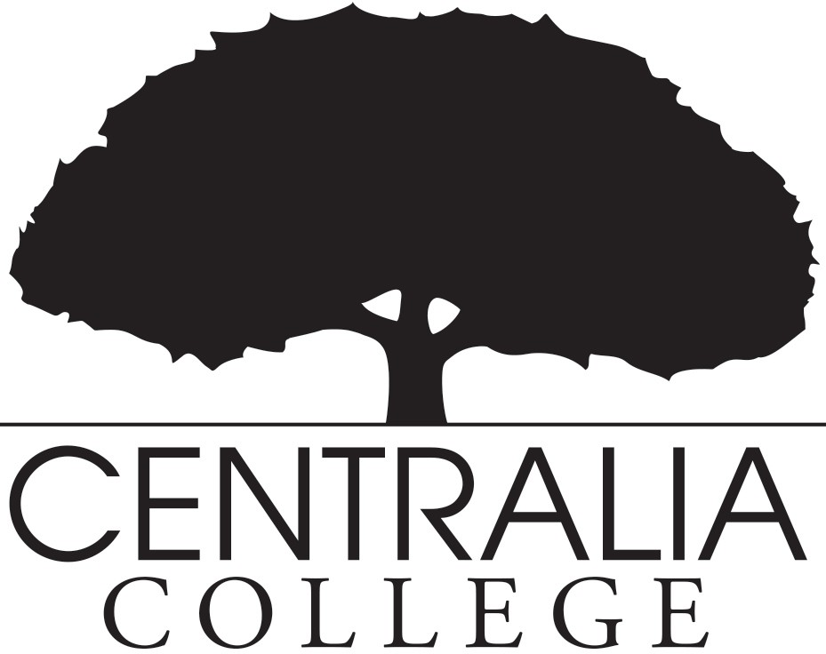 REQUEST FOR SERVICES

Name Student ID Mailing Address City State Zip Phone Email address
Check if you have requested services from:
□ DVR (Dept. of Voc. Rehab.)
Name of Counselor or contact person
□ L&I (Labor & Industries)
□ Services for the Blind
- Please identify your disability (Check all that apply):

Deaf/Hard of Hearing
□

Mobility (Limited ROM)
□

Speech/language
□
(Articulation Disorder)

LD/ADHD/ADD (Specific Learning Disability, Attention Deficit, Processing Disorder)
□

Blind/Visual Impairment

Chronic Health (Cancer, Orthopedic Conditions, Organ & Immune Disorders)
□
□

Neurological (Seizures, Head Injury, Developmental Disability)
□

Psychological (Autism, Mental Health Disorders, Eating Disorders)

Unsure
□
□

Other (please specify)
□

- Please identify the accommodations you are requesting:

  - Sign Language Interpreter
  - FM System
  - Ergonomic Equipment (Chair, Keyboard)
  - Reader/Scribe
  - Adaptive Equipment
□
Notetaker (Copy of class notes)
  - Ability to record lectures
  - Other

  - Large print (Size/Font) Testing (Time + ½, Reduced distraction space)
  - Assistive Technology (Please specify) (Dragon Nat. Speaking, Zoomtext, Kurzweil
□

Scan/Read)

Alternate Format Books/CD
□

I hereby understand that the confidentiality of my records is protected under the Family Educational Rights and Privacy Act (FERPA) and that information contained within the Centralia College file in the Disability Services office may be shared with other members of the staff and faculty for the purpose of receiving reasonable accommodations.

Signature Date

Centralia College does not discriminate against any person on the basis of race, color, national origin, disability, sex, genetic information, or age in admission, treatment, or participation in its programs, services and activities, or in employment. All inquiries regarding compliance with access, equal opportunity and/or grievance procedures should be directed to the Vice President of Human Resources and Equity, Joy Anglesey, Centralia College, 600 Centralia College Blvd, Centralia, WA 98531, 360-623-8943, or joy.anglesey@centralia.edu.

