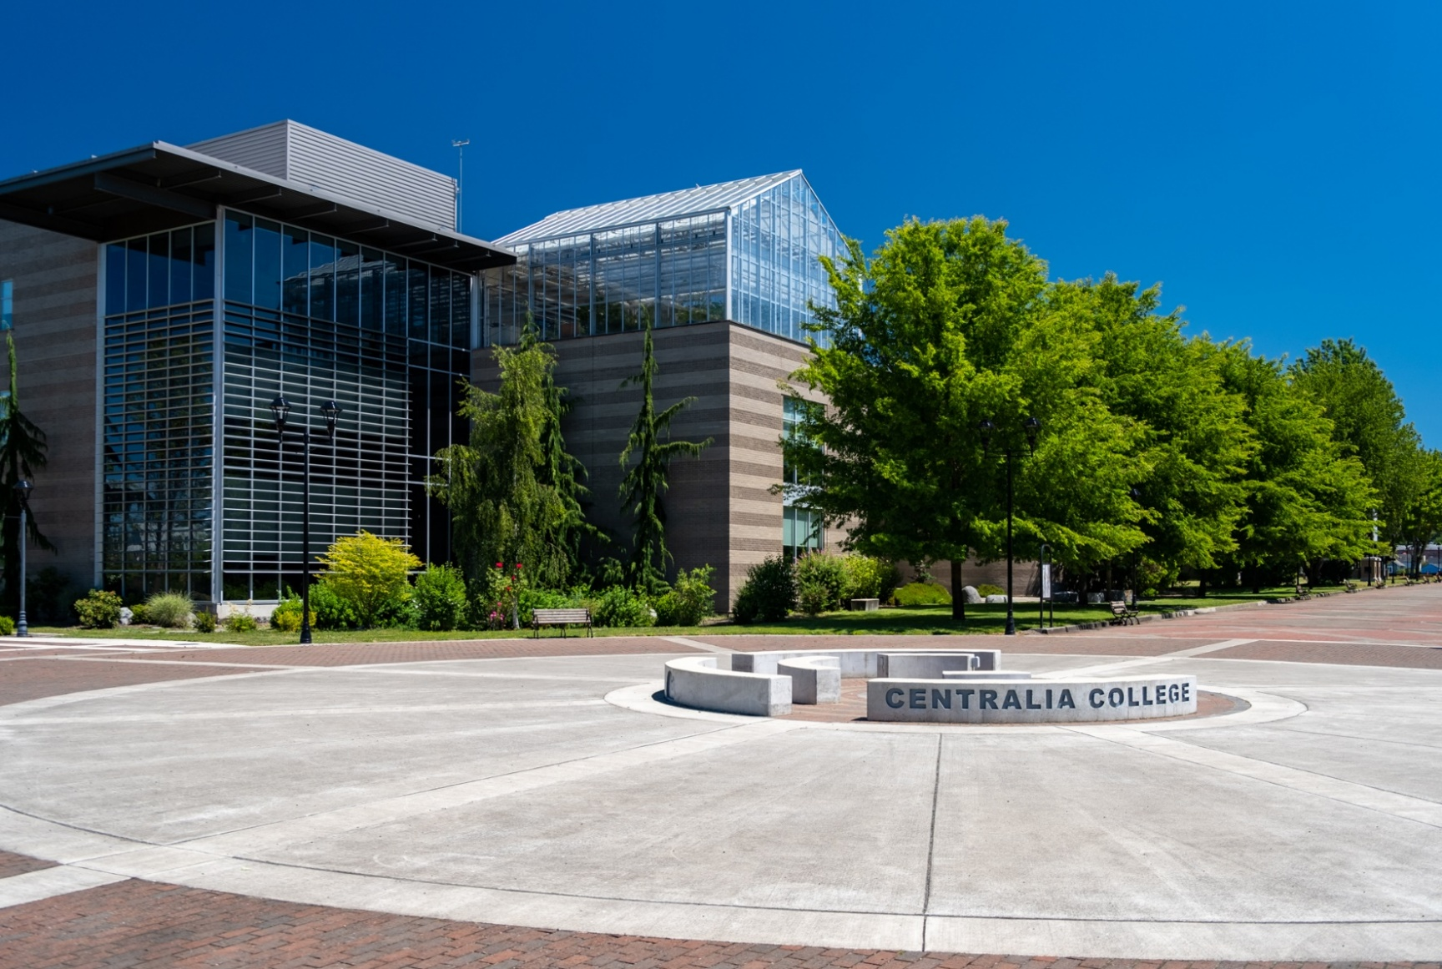

Centralia College
2025 Financial Report



Centralia College
600 Centralia College Boulevard
Centralia, WA
(360) 736-9391

The oldest continuously operated community college in Washington State, since 1925

Centralia College
June 30, 2024
Financial Report

Table of Contents
Letter from the president 5
Board of Trustees and Administrative Officers 6
Independent Auditor’s Report on Financial Statements 7
Management Discussion & Analysis 11
Financial Statement 23
Audited Financial Statements of Component Unit 27
Notes to Financial Statements 32
Schedule of Required Supplementary Information 70

For information about the financial data included in this report, contact:

Tariq Qureshi, Vice President of Finance & Administration
Centralia College
600 Centralia College Blvd
Centralia, WA 98531
(360) 623-8401

CTAP Students Help Rochester Kids



Students in the Construction Trades Apprenticeship Preparation program at Cedar Creek Corrections Center created two custom bus stops, which were donated to Littlerock Elementary School for their Winterfest fundraiser on December 7th. The funds raised from the auction support school programs such as field trips, sports and music, enriching the lives of local students. Each bus stop was meticulously painted and detailed inside and out, showcasing the craftmanship and pride of the students.

Nursing has Perfect Retention this Fall

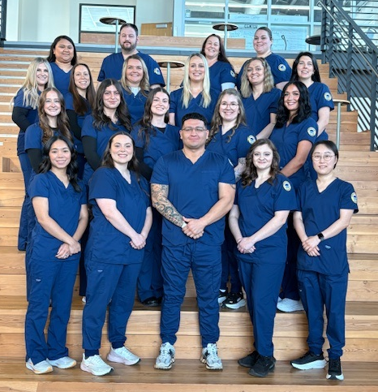
Nursing had a 100 percent retention rate for first-year students moving from spring to fall quarter, with 28 students on track to graduate in June. The program’s first winter cohort is set to receive their pins in March 2026. A second cohort was added last spring.

Aman Gill’s Award-Winning Research


Electronics, Robotics and Automation Professor Aman Gill received a Best Paper award for research that he then presented at the American Society of Mechanical Engineers International Mechanical Engineering Conference and Exposition in Portland in November. The research was a collaboration between Centralia College, University of Washington-Tacoma, Clemson University and Embry Riddle Aeronautical University and sought to compare alignment of vision-based AI with human image recognition systems. Competition was tough, with other winners hailing from University of California Berkeley, Texas Technical University, University of Stuttgart (Germany), National Taiwan University, and State University of Campinas (Brazil). Congratulations, Aman!

Letter from the President

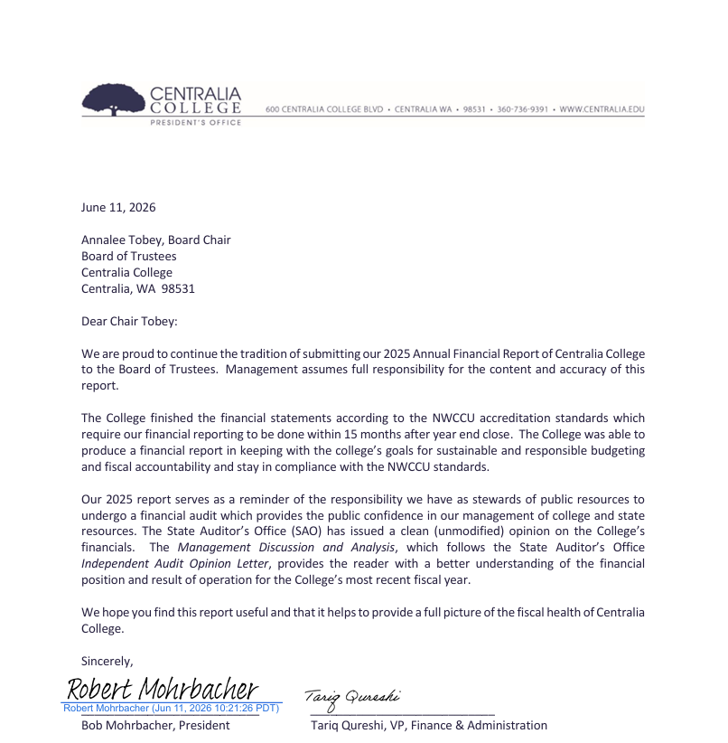

Board of Trustees and Administrative Officers

Board of Trustees
Annalee Tobey, Chair
Pretrina Mullins, Vice Chair
Mark Scheibmeir, Trustee
Court Stanley, Trustee
Chris Thomas, Trustee

Administration
Bob Mohrbacher, Ed.D., President
Connie Smejkal, M.M., Vice President of Instruction
Robert Cox, Ed.D., Vice President of Student Services
Joy Anglesey, MBA, Vice President of Human Resources & Equity
Tariq Qureshi, MBA, Vice President of Finance & Administration
Christine Fossett, Associate Vice President of Advancement
Fia Eliasson-Creek, M.A., Exec. Director of Institution Research & Planning
Nikki Sprague, Exec. Director of Budget & Finance
Carrisa Brower, Director of Fiscal & Business Services

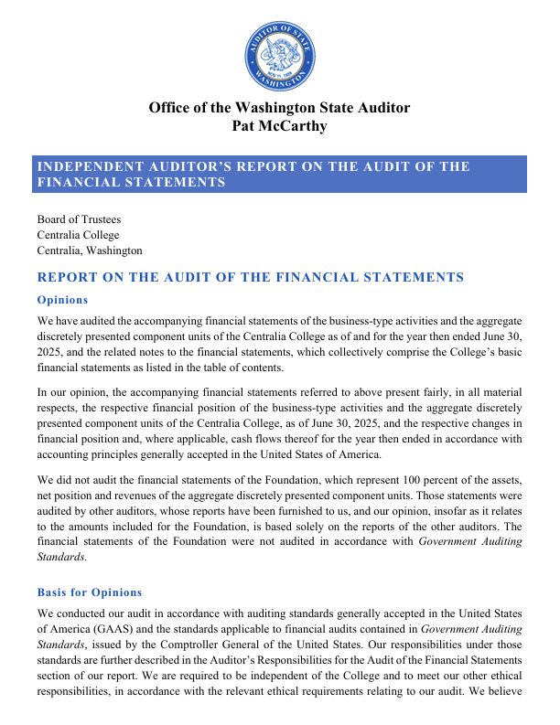
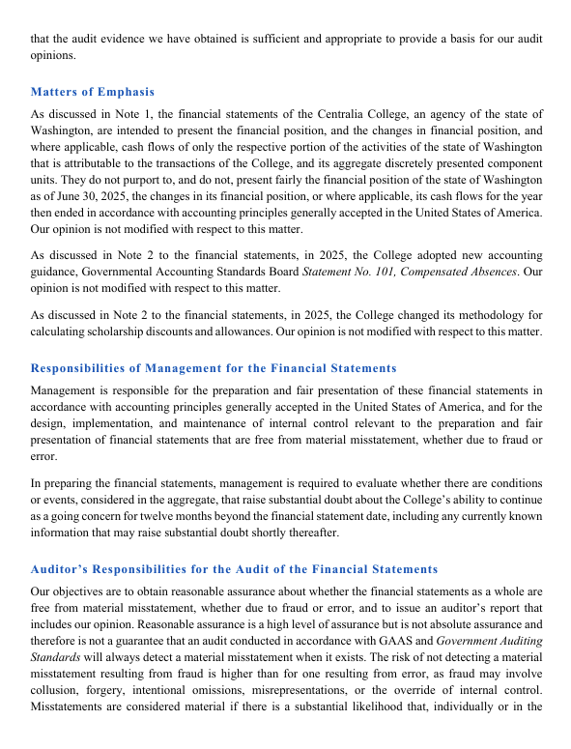
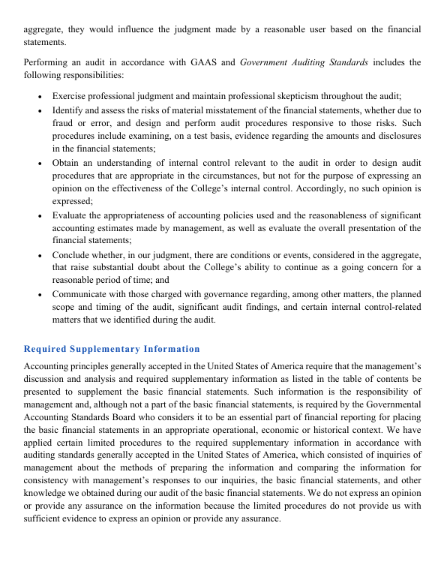
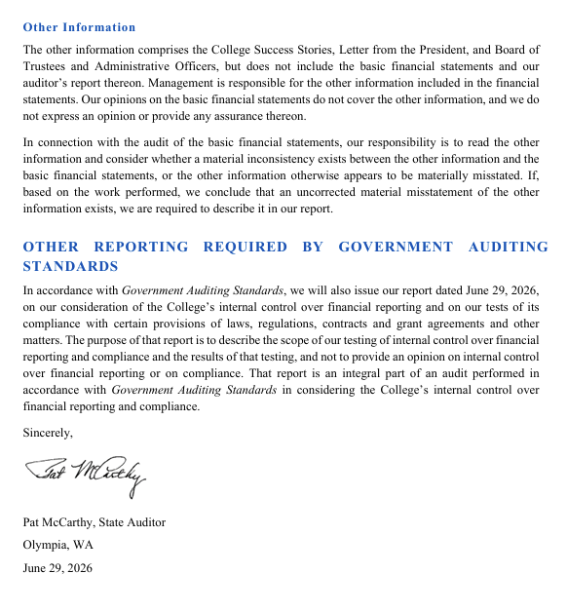
MANAGEMENT’S DISCUSSION & ANALYSIS
Centralia College

The purpose of this Management’s Discussion and Analysis is to provide readers with a clear understanding of Centralia College’s financial position and operating results for the fiscal year ended June 30, 2025, with comparative data for the prior year. This analysis, prepared by college management, should be reviewed in conjunction with the accompanying financial statements and notes. Unless otherwise indicated, all references to years pertain to the fiscal year ending June 30.

Centralia College’s financial report includes information for both the College and its discretely presented component unit, the Centralia College Foundation. As an agency of the State of Washington, the College’s financial data is incorporated into the State’s Annual Comprehensive Financial Report (ACFR) for FY2025.
Reporting Entity

Centralia College is one of 34 community and technical college districts governed by the State Board for Community and Technical Colleges (SBCTC). Oversight is provided by a five-member Board of Trustees appointed by the Governor and confirmed by the Senate for five-year terms. The Board exercises broad authority to supervise, coordinate, and regulate College operations in accordance with state law.

The College offers a range of associate degrees, certificates, and five applied baccalaureate programs. Established in 1925, Centralia College is the oldest continuously operating two-year public college in Washington. It serves approximately 4,840 full- and part-time students annually, primarily in Lewis and southern Thurston counties (population ~130,000). The main campus is in Centralia, with a satellite campus in Morton.

Using the Financial Statements
Centralia College reports as a special-purpose government engaged in business-type activities, consistent with GASB Statement No. 35, Basic Financial Statements – and Management’s Discussion and Analysis – for Public Colleges and Universities, as amended. Under this model, the College presents three primary financial statements:

- Statement of Net Position
- Statement of Revenues, Expenses, and Changes in Net Position
- Statement of Cash Flows

These statements are prepared in accordance with U.S. generally accepted accounting principles (GAAP) and GASB standards. All College activities are reported as a single business-type activity within one column of the basic financial statements.

In compliance with GASB Statement No. 39, Determining Whether Certain Organizations Are Component Units, the Centralia College Foundation is included as a discretely presented component unit because it raises and holds resources for the direct benefit of the College.

Financial Position Overview
The Statement of Net Position provides a snapshot of the College’s financial condition at fiscal year-end, detailing assets, deferred outflows, liabilities, and deferred inflows. The residual—net position—represents the College’s net financial position.
For FY2025, Centralia College’s net position increased by $3.1 million compared to FY2024, primarily driven by growth in unrestricted funds. This improvement reflects prudent fiscal management and resource allocation.
A condensed comparison of the Statements of Net Position for June 30, 2025, and 2024 is presented below:

Capital Assets
During fiscal year 2025, the College’s capital assets, including leased assets, increased by a net amount of approximately $48 thousand. This modest increase reflects offsetting activity across several asset categories. Leased Asset decreased by approximately $71,000. Construction in progress decreased by $976 thousand, primarily due to the completion of major projects—Student Housing, Site Walk, and IT Upgrades—which resulted in the transfer of $1.08 million from construction in progress to buildings and improvements other than buildings. The decrease was partially offset by additional construction costs of $104 thousand related to the ongoing Teachers Education and Family Development building project.
Infrastructure and improvements other than buildings, net of depreciation, increased by $2.08 million. This growth was driven by the capitalization of the Site Walk and IT Upgrades projects, along with additions such as new bleachers, fire alarm improvements, and a donation of batting cages made by the Centralia College Foundation. Buildings saw a $1.6 million increase from the completion of the Student Housing project; however, this was more than offset by depreciation and the sale of property at 512 West Pear, resulting in a net decrease of $710,000. The property sale also contributed to a $65,000 reduction in land. Equipment decreased by $209,000, primarily due to depreciation. Additional details on the College’s capital assets can be found in Note 7 to the financial statements.

Other Assets
Other assets, which include both current and non-current categories, decreased by approximately $240 thousand in fiscal year 2025. Current assets—comprising of cash, investments, accounts receivable, and inventories—rose by $786 thousand compared to fiscal year 2024. This increase was primarily driven by the following factors:
- Cash increased by $1.7 million, reflecting normal fluctuations in operating cash flows.
- Current investments grew by approximately $1.1 million as certain bond holdings transitioned from non-current to current status, consistent with the College’s laddered investment strategy.
- Accounts receivable declined by $2.1 million, attributable to enhanced efficiencies in financial aid processing, billing, and collection activities.
- Inventories increased by $59 thousand.
Non-current assets, excluding capital assets, decreased by $1 million. The decline was largely due to a $633 thousand decrease in long-term investments, a $534 thousand reduction in the net pension asset receivables and a $131 thousand decrease in long-term lease receivables. These decreases were partially offset by a $268 thousand increase in restricted cash.

Deferred Outflows and Inflows
Deferred outflows and inflows of resources primarily relate to pension and other postemployment benefits (OPEB) in accordance with GASB Statements No. 68 and No. 75. Deferred outflows increased in fiscal year 2025, reflecting the College’s proportionate share of statewide amounts reported by the Department of Retirement Systems (DRS) and the Health Care Authority (HCA). This increase is attributable to differences between expected and actual experience based on actuarial assumptions. The College reported $5.77 million in deferred outflows in fiscal year 2024 and $6.10 million in fiscal year 2025.
Conversely, deferred inflows decreased by $1.6 million in fiscal year 2025. This reduction primarily reflects variances between actual and projected investment earnings on the state’s pension plans and OPEB programs, as well as adjustments related to lease receivables. Deferred inflows totaled $10.93 million in fiscal year 2024 compared to $9.32 million in fiscal year 2025.

Other Liabilities
Other liabilities include accounts payable, accrued payroll, the current portion of Certificate of Participation (COP) debt, associated liabilities, and unearned revenues. These balances can fluctuate annually based on the timing of vendor invoicing and payments, particularly for capital asset and improvement projects.
Current liabilities increased by approximately $60 thousand in fiscal year 2025. This change was primarily driven by an $867 thousand increase in the current portion of compensated absences due to implementation of GASB 101, a $168 thousand increase in unearned revenue, and a small increase of $21 thousand in the current portion of pension and OPEB liability. These increases were partially offset by a $303 thousand decrease in accounts payable, a $650 thousand reduction in accrued liabilities, and a $44 thousand decrease of leases and COP payable.

Long-Term Liabilities
Long-term liabilities consist of pension and other postemployment benefit (OPEB) obligations, compensated absences, and the non-current portions of Certificate of Participation (COP) debt and lease payables. Non-current liabilities decreased by approximately $1.4 million in fiscal year 2025, primarily due to reductions in pension-related obligations and compensated absences.
Key changes from fiscal year 2024 to fiscal year 2025 include:
- A $588 thousand decrease in compensated absences (due to implementation of GASB 101)
- A $159 thousand reduction in COP debt
- A $570 thousand decrease in net pension liabilities
- A $99 thousand decline in the OPEB liability
These decreases reflect actuarial adjustments and scheduled debt repayments, contributing to an overall improvement in the College’s long-term liability position.

Net Position
Net position represents the difference of the College’s assets and deferred outflows of resources, less liabilities and deferred inflows of resources, and serves as an indicator of overall financial condition. The College reports net position in three categories:
- Net Investment in Capital Assets – This category reflects the College’s investment in property, plant, and equipment, net of accumulated depreciation and related outstanding debt. Restricted cash and cash equivalents collected for capital projects but not yet expended are excluded from this category and reported as part of restricted net position, expendable.
- Restricted Net Position, Expendable – These resources are subject to externally imposed restrictions that require their use for specific purposes. In addition to the net pension asset associated with state retirement systems, the College’s primary expendable funds include dedicated student fees collected through referendums and reserved for designated projects.
- Unrestricted Net Position – This category encompasses all other resources available for general operations and educational purposes. While unrestricted net position is not externally restricted, the College internally designates the majority of these funds for academic and support functions. Prudent balances are maintained to provide working capital, reserves for emergencies, and other strategic purposes, consistent with policies established by the Board of Trustees.

Statement of Revenues, Expenses and Changes in Net Position
This statement provides detailed information on the factors contributing to changes in the College’s net position during the fiscal year. Revenues and expenses are classified as either operating or non-operating in accordance with GASB requirements.
Operating revenues represent amounts earned by the College in exchange for providing goods and services, while operating expenses include costs incurred in the normal course of operations, including depreciation on capital assets. The difference between operating revenues and operating expenses consistently results in an operating loss because state operating appropriations and federal Pell Grant revenues are reported as non-operating revenues under GASB standards.
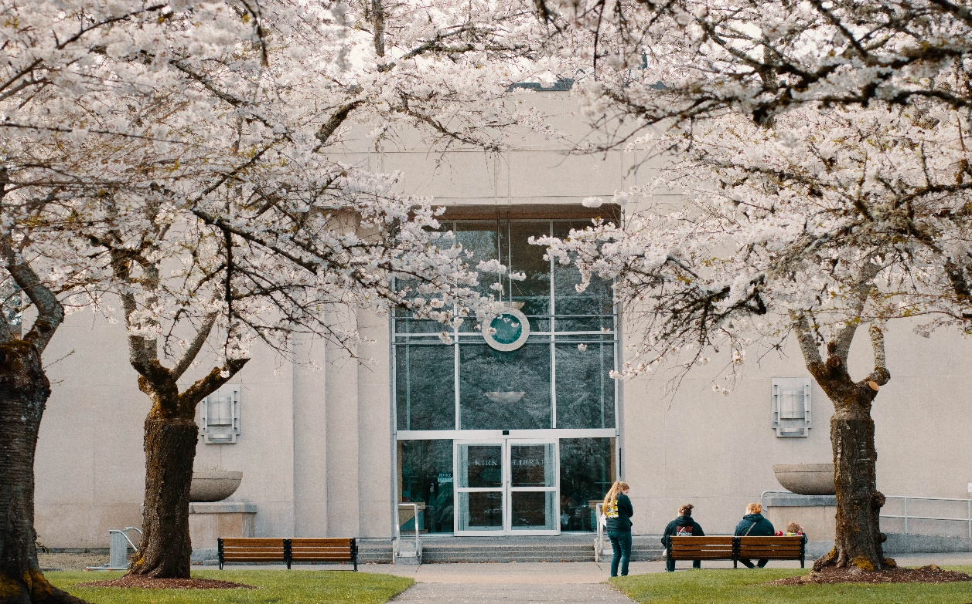

Summary of Revenues, Expenses, and Changes in Net Position
The following table presents a comparative summary of the College’s Statements of Revenues, Expenses, and Changes in Net Position for the fiscal years ended June 30, 2025 and 2024:

Operating and Non-Operating Revenues
The College’s primary sources of funding for academic programs include state operating appropriations, tuition and fees (net of scholarship discounts and allowances), and grants and contracts. These revenue streams form the foundation for delivering educational services and supporting institutional operations.
Revenues
The State of Washington appropriates funds to the community and technical college system, which are then allocated to individual colleges by the State Board for Community and Technical Colleges (SBCTC). In fiscal year 2025, allocations were based on a three-year average of actual full-time equivalent (FTE) enrollments. Changes to the SBCTC allocation formula will be implemented starting in FY27; allocation will be based on a combination of criteria, including FTE, student headcount, student achievement data, and some additional criteria.
State-supported enrollments increased by 2% (51 FTEs) in fiscal year 2025, accompanied by a 2.36% tuition rate increase. Enrollment trends have continued to recover gradually following the sharp declines associated with the COVID-19 pandemic, and revenues generally reflect these enrollment patterns. Accordingly, the College experienced an increase in enrollment and related revenue during fiscal year 2025.
Operating grant and contract revenues rose by approximately $1.1 million compared to fiscal year 2024. This is due to an increase in State and local grants and contracts, while federal grant revenues remained relatively unchanged. The most significant changes within state and local grants included a $400 thousand increase in BFET funding, a new $91 thousand special project grant from Corrections, and a $686 thousand increase in ECEAP funding. Additional smaller increases and decreases across various programs contributed to the net change.
Total non-operating revenues increased by $2.8 million compared to fiscal year 2024. This growth was driven by a $1.7 million increase in state appropriations and a $744 thousand increase in Pell Grant revenue. There was also a gain on asset disposals as compared to a loss in fiscal year 2024 for a total increase of $611 thousand. These increases were partially offset by a $218 thousand decline in investment income.
The College receives capital spending authority on a biennial basis, with the ability to carry forward unexpended amounts into subsequent biennia, subject to the original funding purpose. In accordance with accounting standards, capital appropriation revenue reflects amounts expended during the current year. Capital appropriation revenue increased by $358 thousand in fiscal year 2025 compared to fiscal year 2024. Expenditures for capital projects that do not meet capitalization criteria are reported as operating expenses, while those that qualify for capitalization are recognized as depreciation expense over the useful life of the asset.

Revenue by Source
The following illustration presents the composition of revenues—both operating and non-operating—used to fund the College’s programs for the fiscal years ended June 30, 2025 and 2024, expressed as percentages by source

Operating Expenses
Total operating expenses increased by approximately $3.2 million in fiscal year 2025. Salary costs rose by $1.4 million, reflecting cost-of-living adjustments of 3% for staff and 5.9% for faculty. Benefit costs increased by $369 thousand, primarily due to higher salary-related benefits, partially offset by a $236 thousand increase in pension and OPEB expense reductions. There was also a $216 thousand rise in scholarships and fellowships, a $613 thousand increase in supplies and materials, and a $642 thousand increase in purchased services. The remaining net increase resulted from several smaller fluctuations across various expense categories.

Operating Expense Composition
The College’s major program support costs consist of salaries and wages, employee benefits, scholarships, fellowships, and other forms of student aid. These categories represent the largest share of operating expenses, followed by costs for supplies, materials, and purchased services, as well as depreciation and utilities.

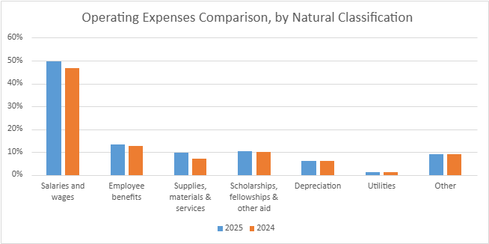

Capital Assets and Long-Term Debt Activities
The community and technical college system submits a consolidated, prioritized request for capital appropriations to the Office of Financial Management and the Legislature. This request encompasses major and minor projects, repairs, emergency funding, alternative financing, and major leases. The primary funding source for college capital projects continues to be state-issued general obligation bonds. In recent years, declining state revenues have reduced overall debt capacity, a trend that is expected to limit the number of new projects financed in the near term.
As of June 30, 2025, the College had invested $85.9 million in capital assets, net of accumulated depreciation—an increase of approximately $119 thousand compared to the prior year. A detailed summary of capital assets is presented in the table below.

The increase in net capital assets during fiscal year 2025 was primarily driven by a $4.4 million increase in buildings and infrastructure improvements. This growth was offset by a $2.9 million increase in accumulated depreciation and $1.4 million in asset retirements and reclassifications. Additional details regarding capital assets are provided in Note 7 to the financial statements.
The College also reports right-to-use leased assets as part of its capital assets in accordance with GASB Statement No. 87, Leases, implemented in fiscal year 2022. These assets decreased in fiscal year 2025 due to amortization of $70,917. The amounts presented in the accompanying table are reported net of accumulated amortization.

As of June 30, 2025, the College reported $1.88 million in outstanding debt, a decrease of $110 thousand compared to the prior year, as shown in the accompanying table. The College entered into a Certificate of Participation (COP) agreement for the TransAlta Building in fiscal year 2017. In fiscal year 2022, the College implemented GASB Statement No. 87, Leases, and recorded a right-to-use lease asset for the Southwest Washington Flexible Trades (SWFT) building, which remains part of the College’s long-term obligations.

Further details regarding lease payables, notes payable, debt service requirements, and long-term liabilities are provided in Notes 12, 13, 14, and 15 to the financial statements.

Financial Summary and Economic Factors Affecting the Future
The Washington State operating budget currently faces an estimated deficit of $1 billion for the current biennium. The Governor’s proposed budget relies on expenditure reductions to address this shortfall. While the specific impact on Centralia College remains uncertain, it is clear that no new funding will be available from the Legislature in the upcoming session. At the same time, inflationary pressures continue to drive operating costs upward. Although local revenues are increasing modestly in line with current enrollment trends, this growth may not be sufficient to offset rising expenditures.
Under the newly approved allocation model adopted by the State Board for Community and Technical Colleges, Centralia College anticipates a reduction of approximately $90,000 in state funding annually over the next six fiscal years. While this reduction is considered manageable and may be partially mitigated by enrollment growth, it will require careful financial planning.
Additionally, ongoing uncertainty at the federal level continues to create volatility in funding for certain programs. This uncertainty is expected to persist over the next three years, adding further complexity to the College’s financial outlook.

Financial Statements
Centralia College Statement of Net Position
As of June 30, 2025
The accompanying notes are an integral part of this statement

Centralia College Statement of Revenues, Expenses and Changes in Net Position
For the Year Ended June 30, 2025
The accompanying notes are an integral part of this statement
Centralia College Statement of Cash Flows
For the Year Ended June 30, 2025

The accompanying notes are an integral part of this statement
Centralia College Statement of Cash Flows – Continued
For Year Ended June 30, 2025

The accompanying notes are an integral part of this statement

Audited Financial Statements of Component Unit

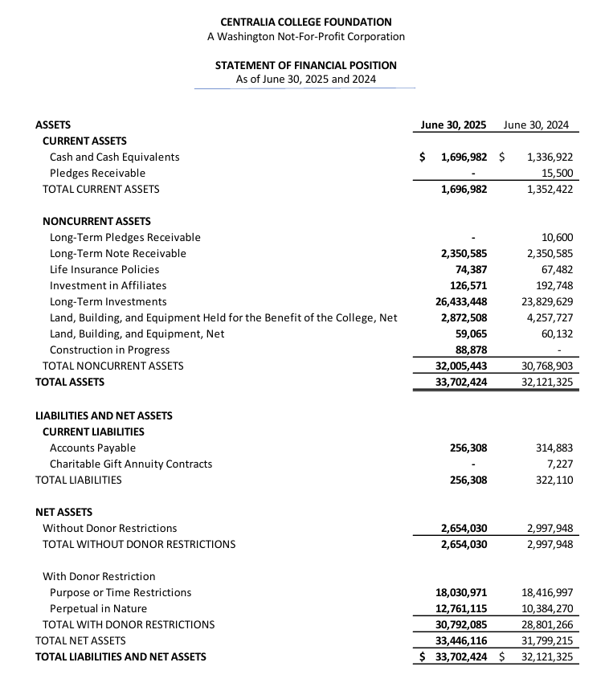

The accompanying notes are an integral part of this statement
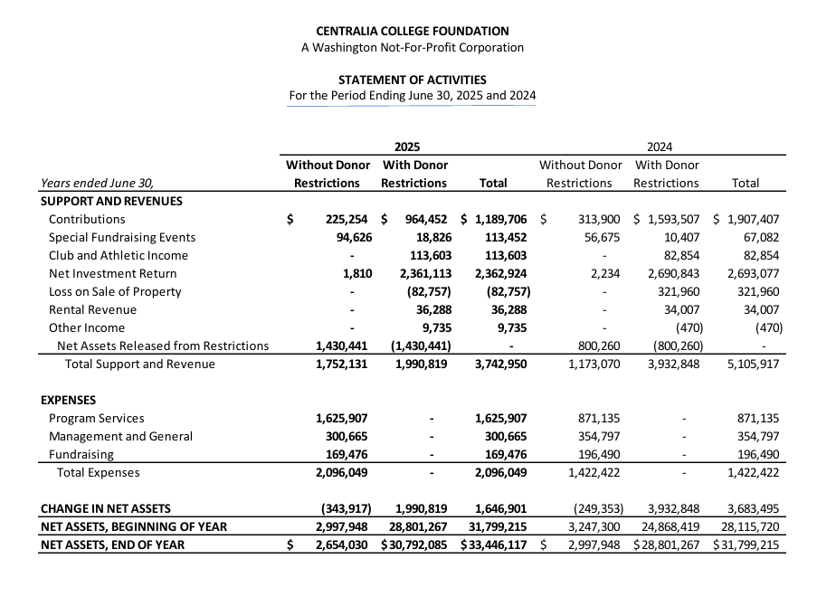

The accompanying notes are an integral part of this statement
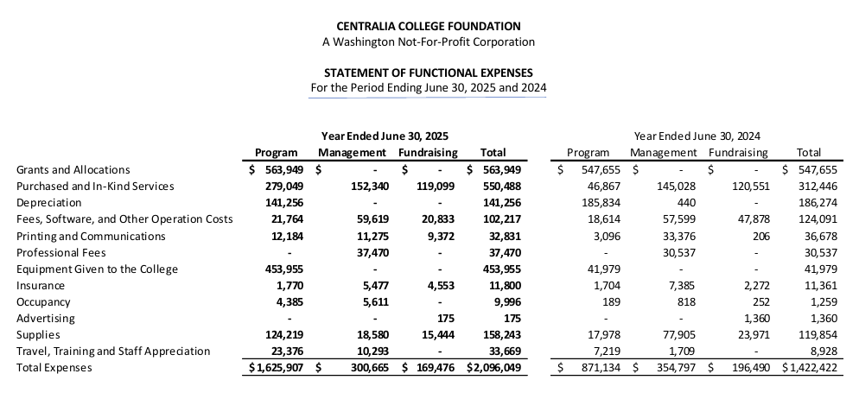

The accompanying notes are an integral part of this statement
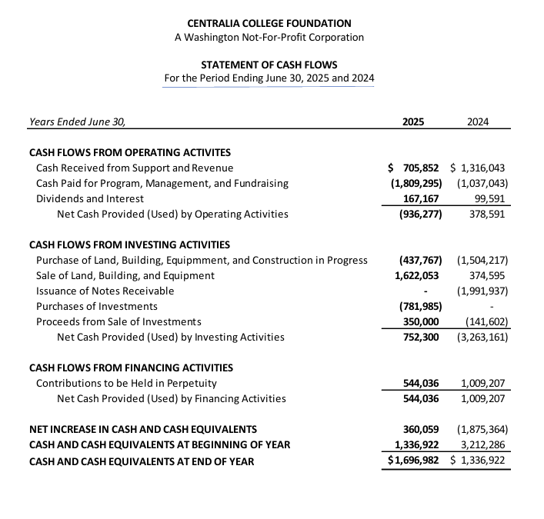

The accompanying notes are an integral part of this statement
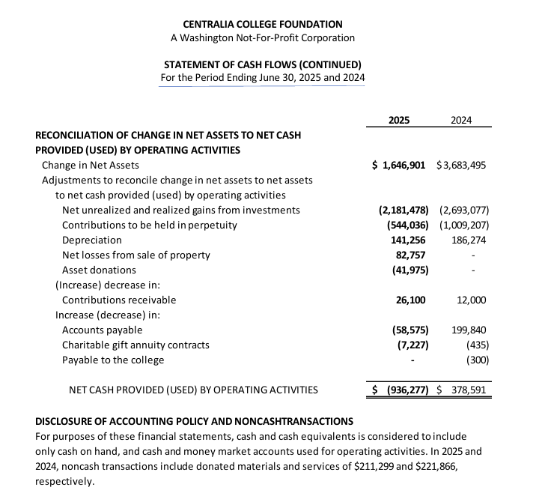

The accompanying notes are an integral part of this statement

Notes to Financial Statements

Note 1. Summary of Significant Accounting Policies
Financial Reporting Entity
Centralia College (“College”) is a comprehensive community college offering open-door academic transfer, workforce education, and basic skill programs, as well as community service and continuing education courses. The College offers applied baccalaureate degrees, associate degrees, certificates and high school diplomas. It is governed by a five-member Board of Trustees, appointed by the Governor and confirmed by the state Senate. The College is an agency of the State of Washington. The financial activity of the College is included in the State’s Annual Comprehensive Financial Report. These notes form an integral part of the financial statements.
The Centralia College Foundation (“Foundation”) is a separate but affiliated non-profit entity, incorporated under Washington law in 1982 and recognized as a tax exempt 501(c)(3) charity. The Foundation’s charitable purpose is to receive gifts, bequests, and donations to be held in trust and administered to advance the goals of Centralia College. Because the majority of the Foundation’s income and resources are restricted by donors and may only be used for the benefit of the college or its students, the Foundation is considered a component unit based on the criteria contained in Governmental Accounting Standards Board (GASB) Statement Nos. 61, 39 and 14. A discrete component unit is an entity which is legally separate from the College, but has the potential to provide significant financial benefits to the College or whose relationship with the College is such that excluding it would cause the College’s financial statements to be misleading or incomplete.
The Foundation’s financial statements are discreetly presented in this report. The Foundation’s statements have been prepared in accordance with accounting principles generally accepted in the United States of America. Intra-entity transactions and balances between the College and the Foundation are not eliminated for financial statement presentation. During the fiscal year ended June 30, 2025, the Foundation distributed approximately $1,061,929 to the College for restricted and unrestricted purposes. A copy of the Foundation’s complete financial statements may be obtained from the Foundation’s Administrative Offices at (360)623-8942.
Basis of Presentation
The financial statements have been prepared in accordance with GASB Statement No. 34, Basic Financial Statements and Management Discussion and Analysis for State and Local Governments as amended by GASB Statement No. 35, Basic Financial Statements and Management Discussion and Analysis for Public Colleges and Universities. For financial reporting purposes, the College is considered a special-purpose government engaged only in Business Type Activities (BTA). In accordance with BTA reporting, the College presents a Management’s Discussion and Analysis; a Statement of Net Position; a Statement of Revenues, Expenses and Changes in Net Position; a Statement of Cash Flows; and Notes to the Financial Statements. The format provides a comprehensive, entity-wide perspective of the college’s assets, deferred outflows, liabilities, deferred inflows, net position, revenues, expenses, changes in net position and cash flows.
Basis of Accounting
The financial statements of the College have been prepared using the economic resources measurement focus and the accrual basis of accounting. Under the accrual basis, revenues are recognized when earned and expenses are recorded when an obligation has been incurred, regardless of the timing of the cash flows. For the financial statements, intra-agency receivables and payables have generally been eliminated. However, revenues and expenses from the College’s auxiliary enterprises are treated as though the College were dealing with private vendors. For all other funds, transactions that are reimbursements of expenses are recorded as reductions of expenses.
Non-exchange transactions, in which the College receives (or gives) value without directly giving (or receiving) equal value in exchange, include state and federal appropriations, and certain grants and donations. Revenues are recognized, net of estimated uncollectible amounts, as soon as all eligibility requirements imposed by the provider have been met.
The preparation of financial statements in conformity with U.S. Generally Accepted Accounting Principles (GAAP) requires management to make estimates and assumptions that affect the reported amounts of assets and liabilities and disclosure of contingent assets and liabilities at the date of the financial statements and the reported amounts of revenue and expenses during the reporting period. Actual results could differ from those estimates.
Cash, Cash Equivalents and Investments
Cash and cash equivalents include cash on hand, bank demand deposits, and deposits with the Washington State Local Government Investment Pool (LGIP). Cash in the investment portfolio is not included in cash and cash equivalents as it is held for investing purposes. Cash and cash equivalents that are held with the intent to fund College operations are classified as current assets along with operating funds invested in the LGIP. The College records all cash and cash equivalents at fair value. Investments in the state’s LGIP, a qualified external investment pool, are reported at amortized cost which approximates fair value. All other investments are reported at fair value.
Accounts Receivable
Accounts receivable consists of tuition and fee charges to students and auxiliary enterprise services provided to students, faculty and staff. This also includes amounts due from federal, state and local governments or private sources as allowed under the terms of grants and contracts. Accounts receivables are shown net of estimated uncollectible amounts.
Leases Receivable
Lease receivables are recorded at the present value of future lease payments expected to be received from the lessee during the term of the lease, reduced by a provision for estimated uncollectible amounts. Lease receivables are subsequently reduced over the life of the lease as cash is received in the applicable reporting period. The present value of future lease payments to be received are discounted using the State of Washington’s incremental borrowing rate unless otherwise noted in the contract term.
Inventories
Inventories consist of merchandise held by auxiliary departments. Inventories are valued at cost, using the First-in First-out (FIFO) valuation method.
Capital Assets
In accordance with state law, capital assets constructed with state funds are owned by the State of Washington. Property titles are shown accordingly. However, responsibility for managing the assets rests with the College. As a result, the assets are included in the financial statements because excluding them would be misleading.
Land, buildings and equipment are recorded at cost, or if acquired by gift, at acquisition value at the date of the gift. GASB 34 guidance concerning preparing initial estimates for historical cost and accumulated depreciation related to infrastructure was followed. Capital additions, replacements and major renovations are capitalized. The value of assets constructed includes all material direct and indirect construction costs. Depreciation is computed using the straight-line method over the estimated useful lives of the assets, excluding intangible right-to-use lease assets and subscription-based IT agreement assets. Routine repairs and maintenance are charged to operating expense in the year in which the expense was incurred.
In accordance with the state capitalization policy:

- Land, including land use rights with indefinite lives acquired with the purchase of the underlying land, and ancillary costs are capitalized
- Infrastructure with a cost of $100,000 or more is capitalized and depreciated over 20-50 years
- Building, building improvements, improvements other than building and leasehold improvements with a cost of $100,000 or more are capitalized and depreciated over 5-50 years
- Lease assets with total payments over the lease term of $500,000 or more are capitalized and amortized over the life of the lease
- All capital assets acquired with Certificates of Participation, are capitalized and depreciated based on the category of asset
- All other capital assets with a unit cost (including ancillary costs) of $5,000 or greater purchased prior to October 1, 2024, or collections with a total cost of $5,000 or greater purchased prior to October 1, 2024, are capitalized and depreciated over 3-50 years depending on specific category of asset. After October 1, 2024, the capitalization threshold was modified to $10,000 to align with new federal guidelines and Washington State Office of Financial Management policy. This change in capitalization threshold did not require any restatements and is prospective only.
The college reviews assets for impairment whenever events or changes in circumstances have indicated that the carrying amount of its assets might not be recoverable. Impaired assets are reported at the lower of cost or fair value. At June 30, 2025, no assets had been written down.
Leases (Lessee)
Right-to-use lease assets are recorded at the initial measurement of the lease liability, plus lease payment made at/or before the commencement of the lease term, less any incentives received from the lessor at/or before the commencement of the lease, plus initial direct costs that are ancillary to place the asset into service. Lease assets are amortized on a straight-line basis over the shorter of the lease term or the useful life of the underlying asset.
Unearned Revenue
Unearned revenues occur when funds have been collected prior to the end of the fiscal year but related to the subsequent fiscal year. Unearned revenues also include tuition and fees paid with financial aid funds. The College has recorded summer and fall quarter tuition and fees and advanced grant proceeds as unearned revenues.
Tax Exemption
The College is a tax-exempt organization under Section 115(1) of the Internal Revenue Code and is exempt from federal income taxes on related income. The Foundation is exempt from income taxes under Section 501(c)(3) of the Internal Revenue Code.

Pension and OPEB Liability
For purposes of measuring the net pension liability in accordance with GASB 68, Accounting and Financial Reporting for Pensions, deferred outflows of resources and deferred inflows of resources related to pensions, and pension expense, information about the fiduciary net position of the State of Washington Public Employees’ Retirement System (PERS) and the Teachers’ Retirement System (TRS) and additions to/deductions from PERS’s and TRS’s fiduciary net position have been determined on the same basis as they are reported by PERS and TRS. For this purpose, benefit payments (including refunds of employee contributions) are recognized when due and payable in accordance with the benefit terms. Investments are reported at fair value.
The College also reports its share of the net pension liability for the State Board Retirement Plan in accordance with GASB 68, Accounting and Financial Reporting for Pensions and Related Assets.
The College reports its share of OPEB liability in accordance with GASB Statement No. 75, Accounting and Financial Reporting for Postemployment Benefits Other than Pensions (OPEB). This Statement requires the College to recognize its proportionate share of the state’s actuarially determined OPEB liability with a one-year lag measurement date similar to GASB Statement No. 68.TES T
Deferred Outflows of Resources and Deferred Inflows of Resources
Deferred outflows of resources represent consumption of net asset that is applicable to a future period. Deferred inflows of resources represent acquisition of net asset that is applicable to a future period.
Deferred inflows related to lease receivable reflect the remaining amount due for all years in the current lease agreement.
Deferred outflows related to pensions are recorded when projected earnings on pension plan investments exceed actual earnings and are amortized to pension expense using a systematic and rational method over a closed period of time. Deferred inflows related to pensions are recorded when actual earnings on pension plan investments exceed projected earnings and are amortized in the same manner as deferred outflows.
Deferred outflows and inflows on pensions also include the difference between expected and actual experience with regard to economic or demographic factors; changes of assumptions about future economic, demographic, or other input factors; or changes in the college’s proportionate share of pension liabilities. These are amortized over the average expected remaining service lives of all employees that are provided with pensions through each pension plan. Employer transactions to pension plans made subsequent to the measurement date are also deferred and reduce pension liabilities in the subsequent year.
The portion of differences between expected and actual experience with regard to economic or demographic factors, changes of assumptions about future economic or demographic factors, and changes in the college’s proportionate share of OPEB liability that are not recognized in OPEB expense should be reported as deferred outflows of resources or deferred inflows of resources related to OPEB. Differences between projected and actual earning on OPEB plan investments that are not recognized in OPEB expense should be reported as deferred outflows of resources or deferred inflows of resources related to OPEB. Employer contributions to the OPEB plan subsequent to the measurement date of the collective OPEB liability should be recorded as deferred outflows of resources related to OPEB.
Net Position
The College’s net position is classified, as follows:
Net investment in capital assets – This represents the College’s total investment in capital assets, net of outstanding debt obligations related to those capital assets.
Restricted for Nonexpendable - This consists of endowment and similar type funds for which donors or other outside sources have stipulated as a condition of the gift instrument that the principal is to be maintained inviolate and in perpetuity and invested for the purpose of producing present and future income which may either be expended or added to the principle.
Restricted net position, expendable – The amount of restricted net pension, expendable includes $1,737,790 for Net Pension Asset using the GASB preferred method which excludes deferred inflows and deferred outflows from the calculation. The total restricted net position, expendable also includes $1,641,419 in which the College is legally or contractually obligated to spend in accordance with restrictions placed by third parties, such as grants, contracts and capital projects.
Unrestricted net position – These represent resources derived from student tuition and fees, and sales and services of educational departments and auxiliary enterprises.
When an expense is incurred that can be paid using either restricted or unrestricted resources, the College’s practice is to first apply the expense towards restricted resources and then towards unrestricted resources.
Classification of Revenues and Expenses
The College has classified its revenues as either operating or non-operating revenues according to the following criteria:
Operating Revenues. This includes activities that are directly related to the principal operations of the College, such as (1) student tuition and fees, net of waivers and scholarship discounts and allowances, (2) sales and services of auxiliary enterprises and (3) federal, state and local grants and contracts that primarily support the operational/educational activities of the colleges. An example would include the contract with OSPI to offer Running Start. The college also receives Adult Basic Education grants that support the primary educational mission of the college.
Operating Expenses. Operating expenses include salaries, wages, fringe benefits, utilities, supplies and materials, purchased services, and depreciation.
Non-operating Revenues. This includes activities that are not directly related to the ongoing operations of the College, such as gifts and contributions, state appropriations, investment income and Pell grants received from the federal government.
Non-operating Expenses. Non-operating expenses include state remittance related to the building fee and the innovation fee, along with interest incurred on the Certificate of Participation Loans.
Scholarship Discounts and Allowances
Student tuition and fee revenue, and certain other revenues from students, are reported net of scholarship discounts and allowances in the Statement of Revenues, Expenses and Changes in Net Position. Scholarship discounts and allowances are the difference between the stated charges for goods and services charged by the College, and the amount that is paid by the students and/or third parties on the students’ behalf. Certain government grants, such as Pell grant, and other Federal, State or non-governmental programs are recorded as either operating or non-operating revenues in the College’s financial statements. To the extent that revenues from such programs are used to satisfy tuition and fees and other student charges, the College has recorded a scholarship discount and allowance. Discounts and allowances for the year ending June 30, 2025 are $4,708,955 in tuition and fees and $234,510 in auxiliary enterprise sales.
State Appropriations
The state of Washington appropriates funds to the State Board of Community and Technical Colleges (SBCTC) which allocates funding to the College on both an annual and biennial basis. These revenues are reported as non-operating revenues on the Statement of Revenues, Expenses and Changes in Net Position, and recognized as such when the related expenses are incurred.
Building and Innovation Fee Remittance
Tuition collected includes amounts remitted to the Washington State Treasurer’s office to be held and appropriated in future years. The Building Fee portion of tuition charged to students is an amount established by the Legislature is subject to change annually. The fee provides funding for capital construction and projects on a system wide basis using a competitive biennial allocation process. The Building Fee is remitted on a monthly basis. The Innovation Fee was established in order to fund the State Board of Community and Technical College’s Strategic Technology Plan. The use of the fund is to implement new ERP software across the entire system. On a monthly basis, the College’s remits the portion of tuition collected for the Innovation Fee to the State Treasurer for allocation to SBCTC. These remittances are non-exchange transactions reported as an expense in the non-operating revenues and expenses section of the statement of revenues, expenses and changes in net position.

Note 2. Accounting and Reporting Changes
In June 2022, the GASB issued Statement No. 101, Compensated Absences, effective FY25. It updates requirements for measuring liability for (1) leave that has not been used, and (2) leave that has been used but not yet paid in cash or settled through noncash means. . A liability should be recognized for leave that has not been used if (a) the leave is attributable to services already rendered, (b) the leave accumulates, and (c) the leave is more likely than not to be used for time off or otherwise paid in cash or settled through noncash means. It also establishes guidance for measuring a liability for leave that has not been used.

The June 30, 2024 compensated absence liability balances were restated as a result of this new standard. Short-term Compensated Absences liability increased by $874,954, while Long-term Compensated Absences liability decreased by $593,230 which resulted in a decrease of net position by $281,724.

In FY25, the college changed the methodology for calculating Scholarship Discounts and Allowances. Prior to FY25, the college calculated Discounts and Allowances using the estimating method endorsed by the National Association of College and University Business Officers (NACUBO). As of FY25, NACUBO is no longer endorsing this method because more accurate data is available directly from college newer Enterprise Resource Planning (ERP) systems. With the implementation of the Washington Community and Technical Colleges’ new ERP system, the college now reports scholarship discounts and allowances to tuition and fees using transactional data from student accounts, which results in more accurate reporting on the financial statements. This change affects the Tuition and Fees revenue and Scholarship expense lines on the Statement of Expenses, Revenues and Changes in Net Position.
Accounting Standards Impacting the Future
In September 2024, GASB issued Statement No. 104, Disclosure of Certain Capital Assets, which was issued to provide essential information about certain types of capital assets. This requires capital assets be disclosed separately by class in capital asset note disclosures and additional disclosures of assets held for sale. The college will implement this statement as required.

In April 2024, the GASB issued Statement No. 103, Financial Reporting Model Improvements, effective FY26. It changes and clarifies requirements of information presented in the MD&A, clarifies operating vs. non-operating revenues and expenses, presentation of major component unit information, and budgetary comparison presentation as RSI. The college has not determined the full impact of this statement.

Note 3. Deposits and Investments
Deposits
Cash and cash equivalents include bank demand deposits, petty cash held at the College and unit shares in the Washington State Treasurer’s Local Government Investment Pool (LGIP). The Office of the State Treasurer invests state treasury cash surpluses where funds can be disbursed at any time without prior notice or penalty. For reporting purposes, pooled investments are stated at amortized cost, which approximates fair value. For purposes of reporting cash flows, the state considers cash and pooled investments to be cash equivalents. Pooled investments include short-term, highly liquid investments that are both readily convertible to cash and are so near their maturity dates that they present insignificant risk of changes in value because of changes in interest rates. For purposes of the statement of cash flows, the College considers all highly liquid investments with an original maturity of 90 days or less to be cash equivalents.

Investments in Local Government Investment Pool (LGIP)
The College is a participant in the Local Government Investment Pool as authorized by Chapter 294, Laws of 1986, and is managed and operated by the Washington State Treasurer. The State Finance Committee is the administrator of the statute that created the pool and adopts rules. The State Treasurer is responsible for establishing the investment policy for the pool and reviews the policy annually and proposed changes are reviewed by the LGIP advisory Committee.

Investments in the LGIP, a qualified external investment pool, are reported at amortized cost which approximates fair value. The LGIP is an unrated external investment pool. The pool portfolio is invested in a manner that meets the maturity, quality, diversification and liquidity requirements set forth by GASB 79 for external investments pools that elect to measure, for financial reporting purposes, investments at amortized cost. The LGIP does not have any legally binding guarantees of share values. The LGIP does not impose liquidity fees or redemption gates on participant withdrawals.

The Office of the State Treasurer prepares a stand-alone LGIP financial report. A copy of the report is available from the Office of the State Treasurer, PO Box 40200, Olympia, Washington 98504-0200, online at http://www.tre.wa.gov.
As of June 30, 2025, the carrying amount of the College’s cash and equivalents was $10,334,059 as represented in the table below.

Cash and cash equivalents include cash and cash equivalents restricted for grants, contracts, Associated Students of Centralia College capital projects and agency clearing funds totaling $1,597,063 on June 30, 2025.

Custodial Credit Risk
Custodial credit risk for bank demand deposits is the risk that in the event of a bank failure, the College’s deposits may not be returned to it. The majority of the College’s demand deposits are with Key Bank. All cash and equivalents, except for change funds held by the College, are insured by the Federal Deposit Insurance Corporation (FDIC) or by collateral held by the Washington Public Deposit Protection Commission (PDPC).

Investment Interest Rate Risk
Interest rate risk is the risk that the College may face should interest rate variances affect the fair value of investments. The College investment policy stipulates that the College manage its exposure to interest rate risk by limiting the duration of investment and structuring the maturity of investments to mature at various points in the year, with a maximum duration for fixed-income securities of 48 months from the time of purchase until maturity.
Although bonds are issued with clearly defined maturities, an issuer may be able to redeem, or call, a bond earlier than its maturity date. The College may then have to consider replacing the called bond with a bond that may have a lower yield than the original yield. The call feature causes the fair value to be highly sensitive to changes in interest rates. Bond maturities, not factoring in any call provision they may contain, mature over the next four years as follows:

Concentration of Credit Risk
Concentration of credit risk is the risk of loss attributable to the magnitude of an investment of a single issuer. Fixed-income securities are subject to credit risk, which is the chance that a bond issuer will fail to pay interest or principal in a timely manner, or that negative perceptions of the issuer’s ability to make these payments will cause security prices to decline. Management believes that obligations of the U.S. government sponsored enterprise (GSE) bonds, such as Fannie Mae (FNMA), Federal Home Loan Bank, Federal Home Loan Mortgage Corporation and Federal Farm Credit Bank or those explicitly guaranteed by the U.S. government, are considered to have minimal concentrations of credit risk.
Investment in Government Securities
The College has $8.649 million in US Government sponsored enterprise bonds, with staggered maturities, in $500,000 -$844,000 amounts. The original maturities ranged from 12 to 48 months. The College has assessed the effects of Statement No. 72 on its investments, and reports investments at fair value. Fair value is defined in the accounting standards as the price that would be received to sell an asset or paid to transfer a liability in an orderly transaction between market participants at the measurement date. Assets and liabilities reported at fair value are organized into a hierarchy based on the levels of inputs observable in the marketplace that are used to measure fair value. Inputs are used in applying the various valuation techniques and take into account the assumptions that market participants use to make valuation decisions. Inputs may include price information, credit data, liquidity statistics and other factors specific to the financial instrument. Observable inputs reflect market data obtained from independent sources. In contrast, unobservable inputs reflect the entity’s assumptions about how market participants would value the financial instrument.
A financial instrument’s level within the fair value hierarchy is based on the lowest level of any input that is significant to the fair value measurement. The following describes the hierarchy of inputs used to measure fair value and the primary valuation methodologies used for financial instruments measured at fair value on a recurring basis:
The College measures and reports investments at fair value using the valuation input hierarchy established by generally accepted accounting principles, as follows:
Level 1 – Prices based on quoted prices in active markets for identical assets or liabilities;
Level 2 – Quoted market prices for similar assets or liabilities, quoted prices for identical or similar assets or liabilities in markets that are not active, or other than quoted prices that are not observable;
Level 3 – Unobservable inputs for an asset or liability.

At June 30, 2025, the College had the following investments:

Note 4. Accounts Receivable
Accounts receivable consists of tuition and fee charges to students and auxiliary enterprise services provided to students, faculty and staff. It also includes amounts due from federal, state and local governments or private sources in connection with reimbursements of allowable expenses made according to sponsored agreements. The major components of accounts receivable as of June 30, 2025, were as follows:

Note 5. Leases Receivable
The College leases a portion of the Transitional Studies Building (TSB) to the Washington State Employment Security Department Payments are monthly based on the contract terms and conditions. Lease receivable are reported net of amortization on the Statement of Net Position. The lease receivable is reported at net present value using the State of Washington’s incremental interest rate unless otherwise noted in the contract term. Revenue recognized under this lease agreement during the year ended June 30, 2025 was as follows:

Note 6. Inventories
Total merchandise inventories for the College Bookstore, Food Services, and the Espresso stand at year-end, stated at cost using the first-in, first-out (FIFO) inventory valuation method was $269,479 at June 30, 2025.

Note 7. Capital Assets
A summary of the changes in capital assets for the year ended June 30, 2025 is presented as follows. The current year net depreciation expense was $3,026,954.

Lease assets as of June 30, 2025 and lease asset activity for the year ended June 30, 2025 are summarized below:

Note 8. Accounts Payable and Accrued Liabilities
At June 30, 2025, accounts payable and accrued liabilities were as follows:

Note 9. Unearned Revenue
Unearned revenue is comprised of receipts which have not yet met revenue recognition criteria, on June 30, 2025, as follows:

Note 10. Risk Management
The College is exposed to various risk of loss related to tort liability, injuries to employees, errors and omissions, theft of, damage to, and destruction of assets, and natural disasters. The College purchases insurance to mitigate these risks. Management believes such coverage is sufficient to preclude any significant uninsured losses for the covered risks.
The College purchases commercial property insurance through the master property program administered by the Department of Enterprise Services for buildings that were acquired with COP proceeds. The policy has a deductible of $250,000 per occurrence and the policy limit is $100,000,000 per occurrence. The college has had no claims in excess of the coverage amount within the past three years. The College assumes its potential property losses for most other buildings and contents.
The College participates in a State of Washington risk management self-insurance program, which covers its exposure to tort, general damage and vehicle claims. Premiums paid to the State are based on actuarially determined projections and include allowances for payments of both outstanding and current liabilities. Coverage is provided up to $10,000,000 for each claim with no deductible. The college has had no claims in excess of the coverage amount within the past three years.
The College, in accordance with state policy, pays unemployment claims on a pay-as-you-go basis. Payments made for claims from July 1, 2024 through June 30, 2025, were $79,365. Cash reserves for unemployment compensation for all employees at June 30, 2025, were $12,830.

Note 11. Compensated Absences
At termination of employment, employees may receive a cash payment for all accumulated vacation and compensatory time. Employees who retire get 25% of the value of their accumulated sick leave credited to a Voluntary Employees’ Beneficiary Association (VEBA) account, which may be used for future medical expenses and insurance purposes. The amounts of unpaid vacation and compensatory time accumulated by employees are accrued when incurred. The sick leave liability is recorded as an actuarial estimate of one-fourth the total balance on the payroll records.
Compensatory time and other miscellaneous leave. Certain college employees earn compensatory time, exchange time, personal holidays, and other miscellaneous leave that accumulates that can either be used for paid time off or may be cashed out in accordance with regulations, collective bargaining agreements, or college policy, as appropriate.

The accrued compensated absence leave liability as of June 30, 2025 totaled $1,000,035 in short-term and $1,308,775 in long-term compensated absence liability. The college uses last-in, first-out (LIFO) when estimating compensated absence liabilities.
An estimated amount, based on a ten-year average payout, is accrued as a current liability. The remaining amount of accrued compensated absence times are categorized as non-current liabilities. Compensatory time is categorized as a current liability since it must be used before other leave.

Note 12. Leases Payable
The College entered into a lease with the Centralia College Foundation for the use of the Southwest Washington Flexible Trades Building (SWFT) on April 1, 2022. The lease liabilities are reported at net present value using the State of Washington’s incremental borrowing rate unless otherwise noted in the contract term. The amount of the lease payments for FY25 were $72,000. This lease has a 42-month term and expires on September 30, 2025.
As of June 30, 2025, the future minimum lease payments under this right-to-use lease consists of the following:

Note 13. Notes Payable
In 2017, the College obtained financing in order to cover the student’s share of the TransAlta Commons through certificates of participation (COP), issued by the Washington Office of State Treasurer (OST) in the amount of $2,595,000 at a premium of $415,668. The premium is to be amortized over the twenty-year term of the loan, at an annual amount of $20,783. The interest rate charged is approximately 3.4%.
The students assessed themselves a mandatory fee to service this debt. Student fees related to the COP are accounted for in a dedicated fund, which is used to pay principal and interest, not coming out of the general operating budget.
The College’s debt service requirements for this note agreement for the next five years and thereafter are as follows in Note 14.

Note 14. Annual Debt Service Requirements
Future debt service requirements at June 30, 2025, are as follows:

Note 15. Schedule of Long-term Liabilities

Note 16. Retirement Plans
A. General
The College offers three contributory pension plans: the Washington State Public Employees’ Retirement System (PERS), the Washington State Teachers’ Retirement System (TRS), and the State Board Retirement Plan (SBRP). PERS and TRS are cost sharing multiple-employer defined-benefit pension plans administered by the Washington State Department of Retirement Systems (DRS). The State Board Retirement Plan (SBRP) is a defined contribution single employer pension plan with a supplemental payment when required. The SBRP is administered by the State Board for Community and Technical Colleges (SBCTC) and available to faculty, exempt administrative and professional staff of the state’s public community and technical colleges. The College reports its proportionate share of the net pension liability as it is a part of the community and technical college system.
Basis of Accounting
Pension plans administered by the state are accounted for using the accrual basis of accounting. Under the accrual basis of accounting, employee and employer contributions are recognized in the period in which employee services are performed; investment gains and losses are recognized as incurred; and benefits and refunds are recognized when due and payable in accordance with the terms of the applicable plan. For purposes of measuring the net pension liability/(asset), deferred outflows of resources and deferred inflows of resources related to pensions, pension expense, information about the fiduciary net position of all plans, and additions to/deductions from all plan fiduciary net position have been determined in all material respects on the same basis as they are reported by the plans.
In accordance with Statement No. 68, the College has elected to use the prior fiscal year end as the measurement date for reporting net pension liabilities.
The following table represents the aggregate pension amounts for all plans subject to the requirements of GASB Statement No. 68 for the College, for fiscal year 2025:
Department of Retirement Systems
As established in chapter 41.50 of the Revised Code of Washington (RCW), the Department of Retirement Systems (DRS) administers eight retirement systems covering eligible employees of the state and local governments. The Governor appoints the director of the DRS.
The DRS administered systems are comprised of 12 defined benefit pension plans and 3 defined benefit/ defined contribution plans. Below are the DRS plans that the College participates in:
• Public Employees’ Retirement System (PERS)
Plan 1 - defined benefit
Plan 2 - defined benefit
Plan 3 - defined benefit/defined contribution
• Teachers’ Retirement System (TRS)
Plan 1 - defined benefit
Plan 2 - defined benefit
Plan 3 - defined benefit/defined contribution
Although some assets of the plans are commingled for investment purposes, each plan’s assets may be used only for the payment of benefits to the members of that plan in accordance with the terms of the plan.
Administration of the PERS and TRS plans is funded by an employer rate of 0.18 percent of employee salaries.
Pursuant to RCW 41.50.770, the College offers its employees that elect to participate a deferred compensation program in accordance with Internal Revenue Code Section 457. The deferred compensation is not available to employees until termination, retirement, disability, death, or unforeseeable financial emergency. This deferred compensation plan is administered by the DRS.
The DRS prepares a stand-alone financial report that is compliant with the requirements of GASB Statement No. 67. Copies of the report may be obtained by contacting the Washington State Department of Retirement Systems, PO Box 48380, Olympia, WA 98504-8380 or online at https://www.drs.wa.gov/wp-content/uploads/2024/10/2024-ACFR-Document-for-Website-sm.pdf.
Higher Education
As established in chapter 28B.10 RCW, eligible higher education state employees may participate in higher education retirement plans. These plans include a defined contribution plan administered by a third party with a supplemental defined benefit component (funded on a pay-as-you-go basis) which is administered by the state.
B. College Participation in Plans Administered by the Department of Retirement Systems
PERS and TRS
Plan Description (PERS)
The Legislature established the Public Employees’ Retirement System (PERS) in 1947. PERS retirement benefit provisions are established in chapters 41.34 and 41.40 RCW and may be amended only by the Legislature. Membership in the system includes: elected officials; state employees; employees of the Supreme Court, Court of Appeals, and Superior Courts (other than judges currently in a judicial retirement system); employees of legislative committees; community and technical colleges, college and university employees not in national higher education retirement programs; judges of district and municipal courts; and employees of local governments.
PERS is a cost-sharing, multiple-employer retirement system comprised of three separate plans for membership purposes: Plans 1 and 2 are defined benefit plans and Plan 3 is a combination defined benefit/defined contribution plan. Although members can only be a member of either Plan 2 or Plan 3, the defined benefit portions of Plan 2 and Plan 3 are accounted for in the same pension trust fund. All assets of this Plan 2/3 defined benefit plan may legally be used to pay the defined benefits of any of the Plan 2 or Plan 3 members or beneficiaries, as defined by the terms of the plan. Therefore, Plan 2/3 is considered a single defined benefit plan for reporting purposes. Plan 3 accounts for the defined contribution portion of benefits for Plan 3 members.
PERS members who joined the system by September 30, 1977, are Plan 1 members. Plan 1 is closed to new entrants. Those who joined on or after October 1, 1977, and by February 28, 2002, for state and higher education employees, or August 31, 2002, for local government employees, are Plan 2 members unless they exercised an option to transfer their membership to PERS Plan 3.
PERS participants joining the system on or after March 1, 2002 have the irrevocable option of choosing membership in either PERS Plan 2 or PERS Plan 3. The option must be exercised within 90 days of employment. Employees who fail to choose within 90 days default to PERS Plan 3.
Benefits Provided
PERS plans provide retirement, disability, and death benefits to eligible members.
PERS Plan 1 members are vested after the completion of five years of eligible service. Plan 1 members are eligible for retirement after 30 years of service, or at the age of 60 with five years of service, or at the age of 55 with 25 years of service. The monthly benefit is 2 percent of the average final compensation (AFC) per year of service, capped at 60 percent. The AFC is the average of the member’s 24 highest consecutive service months.
PERS Plan 1 members retiring from inactive status prior to the age of 65 may receive actuarially reduced benefits. Plan 1 members may elect to receive an optional cost of living allowance (COLA) that provides an automatic annual adjustment based on the Consumer Price Index. The adjustment is capped at 3 percent annually. To offset the cost of this annual adjustment, the benefit is reduced.
PERS Plan 2 members are vested after completing five years of eligible service. Plan 2 members are eligible for normal retirement at the age of 65 with five years of service. The monthly benefit is 2 percent of the AFC per year of service. There is no cap on years of service credit and a COLA is granted based on the Consumer Price Index, capped at 3 percent annually. The AFC is the average of the member’s 60 highest paid consecutive months. PERS Plan 2 members have the option to retire early with reduced benefits.
The defined benefit portion of PERS Plan 3 provides members a monthly benefit that is 1 percent of the AFC per year of service. There is no cap on years of service credit. Plan 3 provides the same COLA as Plan 2. The AFC is the average of the member’s 60 highest paid consecutive months.
PERS Plan 3 members are vested in the defined benefit portion of their plan after 10 years of service; or after five years of service, if 12 months of that service are earned after age 44. PERS Plan 3 members have the option to retire early with reduced benefits. PERS members meeting specific eligibility requirements have options available to enhance their retirement benefits. Some of these options are available to their survivors, with reduced benefits.
Contributions
PERS defined benefit retirement benefits are financed from a combination of investment earnings and employer and employee contributions.
Each biennium, the state Pension Funding Council adopts Plan 1 employer contribution rates, Plan 2 employer and employee contribution rates, and Plan 3 employer contribution rates. The methods used to determine contribution requirements are established under state statute.
Members in PERS Plan 1 and Plan 2 can elect to withdraw total employee contributions and interest thereon, in lieu of any retirement benefit, upon separation from PERS covered employment.
Plan Description (TRS)
The Legislature established the Teachers’ Retirement System (TRS) in 1938. TRS retirement benefit provisions are established in chapters 41.32 and 41.34 RCW and may be amended only by the Legislature. Eligibility for membership requires service as a certificated public-school employee working in an instructional, administrative, or supervisory capacity. TRS is comprised principally of non-state agency employees.
TRS is a cost-sharing, multiple-employer retirement system comprised of three separate plans for membership purposes: Plans 1 and 2 are defined benefit plans and Plan 3 is a defined benefit plan with a defined contribution component. Although members can only be a member of either Plan 2 or Plan 3, the defined benefit portions of Plan 2 and Plan 3 are accounted for in the same pension trust fund. All assets of this Plan 2/3 defined benefit plan may legally be used to pay the defined benefits of any of the Plan 2 or Plan 3 members or beneficiaries, as defined by the terms of the plan. Therefore, Plan 2/3 is considered a single defined benefit plan for reporting purposes. Plan 3 accounts for the defined contribution portion of benefits for Plan 3 members.
TRS members who joined the system by September 30, 1977, are Plan 1 members. Plan 1 is closed to new entrants. Those who joined on or after October 1, 1977, and by June 30, 1996, are Plan 2 members unless they exercised an option to transfer their membership to Plan 3. TRS members joining the system on or after July 1, 1996, are members of TRS Plan 3. Legislation passed in 2007 gives TRS members hired on or after July 1, 2007, 90 days to make an irrevocable choice to become a member of TRS Plan 2 or Plan 3. At the end of 90 days, any member who has not made a choice becomes a member of Plan 3.
Benefits Provided
TRS plans provide retirement, disability, and death benefits to eligible members.
TRS Plan 1 members are vested after the completion of five years of eligible service. Plan 1 members are eligible for retirement at any age after 30 years of service, or at the age of 60 with five years of service, or at the age of 55 with 25 years of service. The monthly benefit is 2 percent of the average final compensation (AFC) for each year of service credit, up to a maximum of 60 percent. The AFC is the total earnable compensation for the two consecutive highest-paid fiscal years, divided by two.
TRS Plan 1 members may elect to receive an optional cost of living allowance (COLA) amount based on the Consumer Price Index, capped at 3 percent annually. To offset the cost of this annual adjustment, the benefit is reduced.
TRS Plan 2 members are vested after completing five years of eligible service. Plan 2 members are eligible for normal retirement at the age of 65 with five years of service. The monthly benefit is 2 percent of the AFC per year of service. A COLA is granted based on the Consumer Price Index, capped at 3 percent annually. The AFC is the average of the member’s 60 highest paid consecutive months. TRS Plan 2 members have the option to retire early with reduced benefits.
The defined benefit portion of TRS Plan 3 provides members a monthly benefit that is 1 percent of the AFC per year of service. Plan 3 provides the same COLA as Plan 2. The AFC is the average of the member’s 60 highest paid consecutive months. TRS Plan 3 members are vested in the defined benefit portion of their plan after 10 years of service; or after five years of service, if 12 months of that service are earned after age 44. TRS Plan 3 members have the option to retire early with reduced benefits.
TRS members meeting specific eligibility requirements have options available to enhance their retirement benefits. Some of these options are available to their survivors, with reduced benefits.
Contributions
PERS and TRS defined benefit retirement benefits are financed from a combination of investment earnings and employer and employee contributions. Each biennium, the state Pension Funding Council adopts Plan 1 employer contribution rates, Plan 2 employer and employee contribution rates, and Plan 3 employer contribution rates. The methods used to determine contribution requirements are established under state statute.
Members in PERS or TRS Plan 1 and Plan 2 can elect to withdraw total employee contributions and interest thereon, in lieu of any retirement benefit, upon separation from PERS or TRS-covered employment.
The employer contribution rates (expressed as a percentage of covered payroll) and actual contributions for the year ended June 30, 2025 were as follows:

Actuarial Assumptions
The total pension liability was determined by an actuarial valuation as of June 30, 2023, with the results rolled forward to the June 30, 2024, measurement date using the following actuarial assumptions, applied to all periods included in the measurement:

Inflation | 2.75%
Salary increases | 3.25%
Investment rate of return | 7.00%
Mortality rates were based on Society of Actuaries’ Pub. H-2010 Mortality rates, which vary by member status (that is…active, retiree, or survivor), as our base table. OSA applied age offsets for each system, as appropriate, to better tailor the mortality rates to the demographics of each plan. OSA applied the long-term MP-2017 generational improvement scale, also developed by the Society of Actuaries, to project mortality rates for every year after the 2010 base table. Mortality rates are applied on a generational basis, meaning members are assumed to receive additional mortality improvements in each future year, throughout their lifetime.
The actuarial assumptions used in the June 30, 2023, valuation were based on the results of the 2013-2018 Demographic Experience Study Report and the 2023 Economic Experience Study. Additional assumptions for subsequent events and law changes are current as of the 2021 actuarial valuation report.
The Office of the State Actuary (OSA) selected a 7.00 percent long-term expected rate of return on pension plan investments using a building-block method. In selecting this assumption, OSA reviewed the historical experience data, considered the historical conditions that produced past annual investment returns, and considered Capital Market Assumptions (CMAs) and simulated expected investment returns provided by the WSIB. The CMAs contain the following three pieces of information for each class of assets the WSIB currently invests in: Expected annual return, Standard deviation of the annual return and, Correlations between the annual returns of each asset class with every other asset class.
The WSIB uses the CMAs and their target asset allocation to simulate future investment returns over various time horizons.
Best estimates of arithmetic real rates of return for each major asset class included in the pension plan’s target asset allocation as of June 30, 2024, are summarized in the following table:

The inflation component used to create the above table is 2.50 percent and represents the WSIB’s most recent long-term estimate of broad economic inflation.
There were no material changes in assumptions, benefit terms, or methods for the reporting period.
Discount Rate
The discount rate used to measure the total pension liability was 7.00 percent. To determine the discount rate, an asset sufficiency test was completed to test whether the pension plan’s fiduciary net position was sufficient to make all projected future benefit payments of current plan members.
Contributions from plan members and employers are assumed to continue to be made at contractually required rates (including PERS Plan 2/3 and TRS Plan 2/3 employers whose rates include a component for the PERS Plan 1 liability). Based on those assumptions, the pension plan’s fiduciary net position was projected to be available to make all projected future benefit payments of current plan members. Therefore, the long-term expected rate of return of 7.00 percent on pension plan investments was applied to determine the total pension liability.
Sensitivity of the Net Pension Liability/(Asset) to Changes in the Discount Rate
The following table presents the net pension liability of the College calculated using the discount rate of 7.00 percent, as well as what the College’s net pension liability would be if it were calculated using a discount rate that is 1-percentage-point lower (6.00 percent) or 1-percentage-point higher (8.00 percent) than the current rate.

Pension Liabilities/(Assets), Pension Expense, and Deferred Outflows of Resources and Deferred Inflows of Resources Related to Pensions
Pension Liabilities/(Assets)
At June 30, 2025, the College reported a total pension liability of $920,687 and a total pension asset of $1,737,790 for its proportionate share of the net pension liabilities/(assets) as follows:

The College’s proportionate share of pension liabilities/(assets) for fiscal years ending June 30, 2023 and June 30, 2024 for each retirement plan are listed below:

The College’s proportion of the net pension liability/(asset) was based on a projection of the College’s long-term share of contributions to the pension plan to the projected contributions of all participating state agencies, actuarially determined.

Pension Expense
For the year ended June 30, 2025, the College recognized pension expense as follows:

Pension Plan | Pension Expense
PERS 1 | $ (57,145)
PERS 2/3 | (81,410)
TRS 1 | (53,561)
TRS 2/3 | 77,129
Total | (114,988)

Deferred Outflows and Inflows of Resources Related to Pensions
The following represent the components of the College’s deferred outflows and inflows of resources as reflected on the Statement of Net Position, for the year ended June 30, 2025:

The $936,237 reported as deferred outflows of resources represent contributions the College made subsequent to the measurement date and will be recognized as a reduction of the net pension liability for the year ended June 30, 2026.

Other amounts reported as deferred outflows and inflows of resources will be recognized in pension expense as follows:

C. College Participation in Plan Administered by the State Board for Community and Technical Colleges
State Board Retirement Plan (SBRP) – Supplemental Defined Benefits Plans
Plan Description
The State Board Retirement Plan is a privately administered single-employer defined contribution plans with a supplemental defined benefit plan component which guarantees a minimum retirement benefit based upon a one-time calculation at each employee’s retirement date. The supplemental component is financed on a pay-as-you-go basis. The College participates in this plan as authorized by chapter 28B.10 RCW and reports its proportionate share of the net pension liability. House Bill 1661, effective fiscal year 2021, created separate Supplemental Retirement Plan (SRP) funds by institution that met the definition of a trust or equivalent arrangement. As a result, this plan has been reported under GASB 67/68 since FY21. Prior to that, the SRP was reported under GASB Statement No. 73. As of June 30, 2024, this plan is being reported with a one year lag between measurement and reporting date. For FY24 this means the measurement date was June 30, 2023 and the reporting date was June 30, 2024.
Benefits Provided
The State Board Supplemental Retirement Plans (SRP) provide retirement, disability, and death benefits to eligible members.
As of July 1, 2011, all the Supplemental Retirement Plans were closed to new entrants.
Members are eligible to receive benefits under this plan at age 62 with 10 years of credited service. The supplemental benefit is a lifetime benefit equal to the amount a member’s goal income exceeds their assumed income. The monthly goal income is one-twelfth of 2 percent of the member’s average annual salary multiplied by the number of years of service (such product not to exceed one-twelfth of fifty percent of the member’s average annual salary). The member’s assumed income is an annuity benefit the retired member would receive from their defined contribution Retirement Plan benefit in the first month of retirement had they invested all employer and member contributions equally between a fixed income and variable income annuity investment.
Plan members have the option to retire early with reduced benefits.
Contributions
Contribution rates for the SBRP (TIAA-CREF), which are based upon age, are 5%, 7.5% or 10% of salary and are matched by the College. Employee and employer contributions for the year ended June 30, 2025, were each $1,024,553.

Actuarial Assumptions
The total pension liability was determined by an actuarial valuation as of June, 2023, with the results rolled forward to the June 30, 2024, measurement date using the following actuarial assumptions, applied to all periods included in the measurement:

The total salary growth, based on the August 2021 Higher Education SRP Experience Study was 3.5% for the community and technical college system.

Mortality rates were developed using the Society of Actuaries’ Pub. H-2010 mortality rates which vary by member status (e.g. active, retiree, or survivor), as the base table. The Office of the State Actuary applied age offsets as appropriate to better tailor the mortality rates to the demographics of each plan. OSA applied the long-term MP-2017 generational improvement scale, also developed by the Society of Actuaries, to project mortality rates for every year after the 2010 base table. Under “generational” mortality, a member is assumed to receive additional mortality improvements in each future year throughout their lifetime.

Discount Rate
The discount rate used to measure the total pension liability was based on the 2021Economic experience study for the Washington State retirement plans and based on the results of the GASB 67/68 required crossover test, or 7.0 percent for the June 30, 2024, measurement date.
Sensitivity of the Net Pension Liability/(Asset) to Changes in the Discount Rate
The following table presents the net pension liability/(asset), calculated using the discount rate of 7.00 percent, as well as what the employers’ total pension liability/(asset) would be if it were calculated using a discount rate that is 1 percentage point lower (6.00 percent) or 1 percentage point higher (8.00 percent) than the current rate:

Pension Liabilities
At June 30, 2025, the College reported a net pension liability of $567,370 for its proportionate share of the net pension liabilities.
The College’s proportionate share of pension liabilities for fiscal years ending June 30, 2023 and June 30, 2024 for the SBRP plan were as follows:

The College’s proportion of the net pension liability as based on the college’s contributions in relation to the contributions of all community and technical colleges in Washington State.
Pension Expense
The Pension Expense is the summation of a number of components, including benefits earned during the fiscal year and interest on the TPL. These numbers are sensitive to assumption changes and plan experience and can be volatile from year to year.
Pension expense for the fiscal year ending June 30, 2025, was ($122,879).
Plan Membership
Membership in the State Board Supplemental Retirement Plan consisted of the following as of January 1, 2024, the most recent full actuarial valuation date.

Number of Participating Members
District | Inactive Members (Or Beneficiaries) Currently Receiving Benefits | Inactive Members Entitled To But Not Yet Receiving Benefits |  | Active Members | Total Members
Centralia College | 14 |  | 12 | 62 | 88

Net Pension Liability/ (Asset)
The following table presents the change in net pension liability/(asset) of the State Board Supplemental Retirement Plan as of June 30, 2024:

Deferred Outflows and Inflows of Resources Related to Pensions
At June 30, 2024, the State Board Supplemental Retirement Plan reported deferred outflows of resources and deferred inflows of resources related to pensions from the following sources:
The $138,364 reported as deferred outflows of resources represent contributions the College made subsequent to the measurement date and are current payments to retirees and Higher Education Retirement plan contributions to fully fund the plan. These payments and contributions will be recognized as a deferred outflow for the year ended June 30, 2026.
Other amounts reported as deferred outflows of resources and deferred inflows of resources related to pensions will be recognized in pension expense in the fiscal year ended June 30:

Note 17. Other Post-Employment Benefits
Plan Description
Per RCW 41.05.065, the Public Employees’ Benefits Board (PEBB), created within the HCA, is authorized to design benefits and determine the terms and conditions of employee and retired employee participation and coverage. PEBB establishes eligibility criteria for both active employees and retirees. Benefits purchased by PEBB include medical, dental, life, and long-term disability.
The relationship between the PEBB OPEB plan and its member employers, their employees, and retirees is not formalized in a contract or plan document. Rather, the benefits are provided in accordance with a substantive plan in effect at the time of each valuation. A substantive plan is one in which the plan terms are understood by the employers and plan members. This understanding is based on communications between the HCA, employers and plan members, and the historical pattern of practice with regard to the sharing of benefit costs. The understanding by the employer and plan members is that there is no contractual obligation to continue the substantive plan as an employee benefit on an ongoing basis. Nevertheless, the actuarial assumptions used in valuations presented in this footnote assume that this substantive plan will be carried forward into the future.
The PEBB OPEB plan is funded on a pay-as-you-go basis. In the state ACFR the plan is reported in governmental funds using the modified accrual basis and the current financial resources measurement focus. For all proprietary and fiduciary funds, the OPEB plan is reported using the economic resources measurement focus and the accrual basis of accounting. The PEBB OPEB plan has no assets and does not issue a publicly available financial report.
Employees Covered by Benefit Terms
The PEBB OPEB plan is available to employees who elect to continue coverage and pay the administratively established premiums at the time they retire under the provisions of the retirement system to which they belong. Retirees’ access to the PEBB plan depends on the retirement eligibility of their respective retirement systems. Membership in the PEBB plan for the College consisted of the following:
Benefits Provided.
Per RCW 41.05.022, retirees who are not yet eligible for Medicare benefits may continue participation in the state’s non-Medicare community-rated health insurance risk pool on a self-pay basis. Retirees in the non-Medicare risk pool receive an implicit subsidy. The implicit subsidy exists because retired members pay a premium based on a claims experience for active employees and other non-Medicare retirees. The subsidy is valued using the difference between the age-based claims costs and the premium.
Retirees who are enrolled in both Parts A and B of Medicare may participate in the state’s Medicare community-rated health insurance risk pool. Medicare retirees receive an explicit subsidy in the form of reduced premiums. Annually, the HCA administrator recommends an amount for the next calendar year’s explicit subsidy for inclusion in the Governor’s budget. The final amount is approved by the state Legislature. In calendar year 2025 the explicit subsidy was $183 per member per month, and it will remain $183 per member per month in calendar year 2026.
Contribution Information
Administrative costs as well as implicit and explicit subsidies are funded by required contributions (RCW 41.05.050) from participating employers. The subsidies provide monetary assistance for medical benefits.
Contributions are set each biennium as part of the budget process. The benefits are funded on a pay-as-you-go basis.
The estimated monthly cost for PEBB benefits for each active employee (average across all plans and tiers) is as follows (expressed in dollars):
For information on the results of an actuarial valuation of the employer provided subsidies associated with the PEBB plan, refer to: http://leg.wa.gov/osa/additionalservices/Pages/OPEB.aspx
Total OPEB Liability
As of June 30, 2025, the state reported a total OPEB liability of $4.376 billion. The College’s proportionate share of the total OPEB liability is $9,404,154. This liability was determined based on a measurement date of June 30, 2024.
Actuarial Assumptions
The actuarial methods and assumptions used include techniques that are designed to reduce the effects of short-term volatility in actuarial accrued liabilities and the actuarial value of assets, consistent with the long-term perspective of the calculations. The total OPEB liability was determined using the following actuarial assumptions, applied to all periods included in the measurement, unless otherwise specified:
In projecting the growth of the explicit subsidy, after 2022 when the cap is $183, it is assumed to grow at the health care trend rates. The Legislature determines the value of the cap and no future increases are guaranteed; however, based on historical growth patterns, future increases to the cap are assumed.
Mortality rates were developed using the Society of Actuaries’ Pub.H-2010 mortality rates which vary by member status (e.g. active, retiree, or survivor) as the base table. The Office of the State Actuary applied age offsets for each system, as appropriate, to better tailor the mortality rates to the demographics of each plan. OSA applied the long-term MP-2017 generational improvement scale, also developed by the Society of Actuaries, to project mortality rates for every year after the 2010 base table. Under “generational” mortality, a member is assumed to receive additional mortality improvements in each future year, throughout their lifetime.
Most demographic actuarial assumptions, including mortality and when members are expected to terminate and retire, were based on the results of the 2013-2018 Demographic Experience Study Report. The post-retirement participation percentage and percentage with spouse coverage, were reviewed in 2017. Economic assumptions, including inflation and salary increases, were based on the results of the 2019 Report on Financial Condition and Economic Experience Study.
Actuarial Methodology
The total OPEB liability was determined using the following methodologies:
The actuarial methodology used to determine the transactions subsequent to the measurement date were as follows:

A retiree subsidy rate of $66.50 per member per month, used to calculate the transactions subsequent to the measurement date, is equal to the total subsidies received by current retirees (both explicit and implicit), divided by the number of current active subscribers. This amount is then allocated to the agency level based on the active, health care eligible employee headcount of each agency as of the measurement date.
Discount Rate
Since OPEB benefits are funded on a pay-as-you-go basis, the discount rate used to measure the total OPEB liability was set equal to the Bond Buyer General Obligation 20-Bond Municipal Bond Index, or 3.65 percent for the June 30, 2023 measurement date and 3.93 percent for the June 30, 2024 measurement date.
Additional detail on assumptions and methods can be found on OSA’s website: http://leg.wa.gov/osa/additionalservices/Pages/OPEB.aspx
Changes in Total OPEB Liability
As of June 30, 2025, components of the calculation of total OPEB liability determined in accordance with GASB Statement No. 75 for the College are represented in the following table:
Sensitivity of the Total Liability to Changes in the Discount Rate
The following represents the total OPEB liability of the College, calculated using the discount rate of 3.93 percent as well as what the total OPEB liability would be if it were calculated using a discount rate that is 1 percentage point lower (2.93 percent) or 1 percentage point higher (4.93 percent) than the current rate:
Sensitivity of Total OPEB Liability to Changes in the Health Care Cost Trend Rates
The following represents the total OPEB liability of the College, calculated using the health care trend rates range of (4.5)%-9.5% reaching an ultimate range of 3.8% in 2080, as well as what the total OPEB liability would be if it were calculated using health care trend rates that are 1% point lower ((3.5%)-8.5%) or 1% higher ((5.5)%-10.5%) than the current rate.

OPEB Expense and Deferred Outflows of Resources and Deferred Inflows of Resources Related to OPEB
For the year ending June 30, 2025, the College will recognize OPEB expense of ($337,436). OPEB expense consists of the following elements:

As of June 30, 2025, the deferred outflows and deferred inflows of resources for the College are as follows:
Amounts reported as deferred outflows of resources and deferred inflows of resources related to OPEB will be recognized as OPEB expense in subsequent years for the College as follows:

The change in the College’s proportionate share of OPEB liability and deferred inflows and deferred outflows of resources based on measurement date are representing in the following table:

Note 18. Operating Expenses by Program
In the Statement of Revenues, Expenses and Changes in Net Position, operating expenses are displayed by natural classifications, such as salaries, benefits, and supplies. The table below summarizes operating expenses by program or function such as instruction, research, and academic support. The following table lists operating expenses by program for the year ending June 30, 2025.

Note 19. Related-Party Transactions
Based on their inter-relationship, the College and the Foundation have a number of transactions with each other during the course of the year. Under a formal agreement between the College and Foundation, the College provides printing, postage, office space, staff services and supplies, which the value totaled a net of $211,299 for 2025, while the Foundation provides fundraising and financial services.
The Foundation distributed approximately $1,061,929 to the College for restricted and unrestricted purposes in 2025. Inter-entity transactions and balances between the College and Foundation are not eliminated for financial statement presentation purposes.

Note 20. Commitments and Contingencies
The College has commitments of $1.6 million for the Teacher Education and Family Development (TEFD) building project. This building is primarily State capital project funded but will require local funds to complete the project. We expect state funding in July 2027.
The College is engaged in various legal actions in the ordinary course of business. Management does not believe the ultimate outcome of these actions will have a material adverse effect on the financial statement.

SCHEDULES OF REQUIRED SUPPLEMENTARY INFORMATION
Pension Plan Information
Cost Sharing Employer Plans
Schedules of Centralia College’s Proportionate Share of the Net Pension Liability

Cost Sharing Employer Plans
Schedules of Centralia College’s Proportionate Share of the Net Pension Liability

Cost Sharing Employer Plans
Schedules of Centralia College’s Proportionate Share of the Net Pension Liability

Cost Sharing Employer Plans
Schedules of Centralia College’s Proportionate Share of the Net Pension Liability

Pension Plan Information
Cost Sharing Employer Plans
Schedules of Contributions

Cost Sharing Employer Plans
Schedules of Contributions

Cost Sharing Employer Plans
Schedules of Contributions

Cost Sharing Employer Plans
Schedules of Contributions

SCHEDULES OF REQUIRED SUPPLEMENTARY INFORMATION
State Board Supplemental Defined Benefit Plans
Note: These schedules will be built prospectively until they contain 10 years of data.

State Board Supplemental Defined Benefit Plans
Notes to Required Supplementary Information
The State Board Supplemental Retirement Plans are financed on a pay-as-you-go basis. State Board makes direct payments to qualifying retirees when the retirement benefits provided by the fund sponsors do not meet the goals, no assets are accumulated in trusts or equivalent arrangements. Potential factors that may significantly affect trends in amounts reported include changes to the discount rate, salary growth and the variable income investment return.
Effective fiscal year 2021, House Bill 1661 created dedicated funds to pay SRP benefits that mimic the trust arrangement for the rest of the state retirement systems. As a result, the plan, previously reported under GASB Statement No. 73 is now being reported under GASB Statement No. 68. In FY24 reporting for the SBRP plan changed a one-year lab between measurement and reporting.
The Schedule of Employer Contributions contains actual amounts, while the notes report contributions as a proportionate share of plan total contributions

SCHEDULES OF REQUIRED SUPPLEMENTARY INFORMATION
Other Postemployment Benefits Information
Note: These schedules will be built prospectively until they contain 10 years of data.
Notes to Required Supplementary Information
The Public Employee's Benefits Board (PEBB) OPEB plan does not have assets in trusts or equivalent arrangements and is funded on a pay-as-you-go basis. Potential factors that may significantly affect trends in amounts reported include changes to the discount rate, health care trend rates, salary projections, and participation percentages.

